California Educator Reporting System User Guide with CAASPP, ELPAC, Smarter Balanced and ETS

# 2020–21 California Educator Reporting System User Guide

Table of Contents

Introduction to the User Guide 1

Organization of the User Guide 1

Document Conventions 1

Text 1

Asides 1

Intended Audience 2

Overview of the California Educator Reporting System 3

Browser Requirements 3

User Roles and Permissions 3

Accessing CERS 7

Logging On 7

Logging Off 11

Understanding the User Interface 12

Home Page 12

Navigation and Menus 13

General Tools 14

Drop-down Lists 14

Live Search 16

Exporting and Downloading 16

Context Menus 17

Column Ordering 17

Sorting 18

Expanding and Collapsing 18

Toggle Buttons 19

Advanced Filters 19

Buttons 20

[Add] and [Remove] Icons 20

Informational Icons 20

Reporting Features in Detail 22

Accessing Interim and Summative Assessment Results 22

Search by Student 22

Student Test History Report 23

Search by School 31

Student Results by School and Grade 32

Student Results Advanced Filters 33

Selected Assessments 34

Student Assessment Results Report 36

Search by Group 36

Student Group Assessment Results 42

Selected Assessments 43

Assessment Results 43

Interim Assessment Results 44

IAB Results By Student 44

IAB Student Options 46

IAB Results By Item 46

IAB Results By Item Details 47

Key / Distractor Analysis 52

IAB Writing Trait Scores 53

IAB Dashboard 54

ICA Results 56

ICA Results By Student 57

ICA Writing Traits Scores 59

Summative Assessment Results 59

Smarter Balanced Summative Assessment Results for ELA and Math 59

ELPAC Summative Assessment Results 62

CAST Results 63

CAA Summative Assessment Results for ELA and Math 64

CSA Results 65

Custom Aggregate Reports 65

Report Type 66

Schools and Districts 66

Assessment Attributes 67

Subgroups and Filters 71

Report Review 74

Report Preview 75

Creating the Custom Aggregate Report 76

District / School Exports 78

My Reports 80

Saved Queries 82

Saving a Query 83

Editing a Saved Query 83

Manage Student Groups 86

Uploading Student Group Files 87

Upload Template File and Validation Rules 88

Working with Upload Files in Microsoft Excel 90

View Uploads 92

Troubleshooting Common Issues 93

Manage Instructional Resources 94

Manage Embargoed Results 95

Technical Support 97

Appendix — Sandbox 98

Generated Data 98

User Roles and Permissions 98

Sandbox Logon 99

Sandbox Session Data 100

List of Tables

Table 1. CERS Implementation Timeline 3

Table 2. LEA Level Test Operations Management System Roles and Associated Permissions 4

Table 3. School Level Test Operations Management System Roles and Associated Permissions 5

Acronyms and Initialisms Used in the California Educator Reporting System User Guide

| **Abbreviation** | **Term** |
| --- | --- |
| CAA | California Alternate Assessment |
| CAST | California Science Test |
| CCSS | Common Core State Standards |
| CERS | California Educator Reporting System |
| CSA | California Spanish Test |
| CSV | comma-separated value |
| ELA | English language arts/literacy |
| ELPAC | English Language Proficiency Assesments for California |
| IAB | Interim Assessment Block |
| ICA | Interim Comprehensive Assessment |
| LEA | local educational agency |
| PII | personally identifiable information |
| SEM | standard error of measurement |
| SSID | Statewide Student Identifier |

## Introduction to the User Guide

This user guide describes the features of the California Educator Reporting System (CERS) and provides detailed instructions for using each feature, including common scenarios that encompass related features.

### Organization of the User Guide

This user guide is organized into the following major sections:

* Overview of the California Educator Reporting System provides a brief introduction to CERS, including the system’s relationship with other Smarter Balanced applications and an overview of user roles and permissions.

Accessing CERS describes how to log on and off CERS, and how to switch to other Smarter Balanced applications.

* Understanding the User Interface outlines the overall layout of the system, including navigation, common tools and tasks, and profile management.

Reporting Features in Detail outlines each reporting feature in-depth, with step-by-step instructions.

* Troubleshooting Common Issues outlines steps users can take when the application is not behaving as expected.

Appendix — Sandbox describes the CERS Sandbox features and functions.

### Document Conventions

#### Text

* Italicized text refers to a page element, such as a menu, page name, or field name.
* Bold text within brackets refers to a selectable button, tab, or icon.
* Underlined Blue text refers to a link.

#### Asides

The following content blocks are used to call attention to a tip, note, caution, or warning that will help users maximize their experience with CERS.

##### Tip



**Tip:** This symbol appears next to text that contains a helpful tip.

##### Note



**Note:** This symbol appears next to text that contains helpful information or reminders.

##### Caution

**Caution:** This symbol appears with text that contains important information regarding a task.



##### Warning

**Warning:** This symbol appears with text that contains extremely important information regarding actions that may cause errors.



### Intended Audience

This user guide is intended for teachers, school administrators, local educational agency (LEA) administrators, and state education agency staff who use CERS for timely and accurate reports on student performance on summative and interim assessments. Users should be familiar with web applications, entering data into form fields, and working with comma-separated value files (CSV).

## Overview of the California Educator Reporting System

The California Educator Reporting System (CERS) allows teachers and administrators to access detailed student performance information for summative and interim assessments. Authorized users of the system can view student data at the relevant district, school, and grade levels. Users with the required permissions may also view, download, and print Individual Student Reports (ISRs). Over the next two years, student results from all CAASPP and ELPAC assessments will be added to CERS. The table below lists, by assessment, when the results from prior years and regular (i.e., daily or weekly) feed of results will be available in CERS.

Table 1. CERS Implementation Timeline

| Assessment Name | Results from Prior Years Available | Regular Feed of Results Available |
| --- | --- | --- |
| Interim Assessments (ICAs and IABs) | Available Now | Available Now |
| ELPAC | Available Now | Spring 2021 |
| Summative assessments for ELA and mathematics | Available Now | Spring 2021 |
| California Alternate Assessments (CAAs) for ELA and mathematics | Available Now | Spring 2021 |
| California Spanish Assessment | Available Now | Spring 2021 |
| California Science Test | Available Now | Spring 2021 |
| CAA for Science | not applicable | Spring 2022 |
| Alternate ELPAC | not applicable | Spring 2022 |

### Browser Requirements

The application is intended to be accessed using a browser from a computer or tablet. It is compatible with all modern browsers, including Google Chrome, Mozilla Firefox, Microsoft Edge Chromium, and Apple Safari. The Internet Explorer browser is not compatible with this system.

### User Roles and Permissions

Access to student information in CERS depends on the user’s role in TOMS and the school(s) or LEA(s) with which the user’s account is associated.

For example, teachers may have permission to view reports for students in personalized student groups, school administrators may view results for all students in the school, and LEA administrators may view results for all students in the LEA. Table 2 and Table 3 show the permissions associated with each role. Note that each role only has permission for its own school, LEA, or state.

**Description of CERS and Tools for Teachers Functions within TOMS Roles**

**PII**: View individual student results by district, school, and grade

**GROUP_ADMIN**: Create/edit/and delete assigned student groups (Assigns student groups to others, such as teachers)

**Custom Aggregate Reporter**: Create/view/export custom aggregate reports

**Instructional Resource Admin**: Create/edit/delete links to instructional resources

**PII_GROUP**: Create/edit/delete custom groups (from assigned groups) – view students (individual or group) in assigned group(s)

**DL_EndUser**: Tools for Teachers user

Table 2. LEA Level Test Operations Management System Roles and Associated Permissions

| TOMS Role Names | Program | Organization Level | Role Functions (for Tools for Teachers and CERS) |
| --- | --- | --- | --- |
| LEA CAASPP Coordinator | CAASPP | LEA | PII, PII_GROUP, GROUP_ADMIN, Custom Aggregate Reporter, Instructional Resource Admin, DL_EndUser |
| LEA ELPAC Coordinator | ELPAC | LEA | PII, PII_GROUP, GROUP_ADMIN, Custom Aggregate Reporter, Instructional Resource Admin, DL_EndUser |
| Educator - District | CAASPP | LEA | PII, PII_GROUP, GROUP_ADMIN, Custom Aggregate Reporter, Instructional Resource Admin, DL_EndUser |
| LST Correspondence Administrator | ELPAC | LEA | PII_GROUP, DL_EndUser |

Table 3. School Level Test Operations Management System Roles and Associated Permissions

| TOMS Role Names | Program | Organization Level | Role Functions (for Tools for Teachers and CERS) |
| --- | --- | --- | --- |
| Site CAASPP Coordinator | CAASPP | School | PII, PII_GROUP, GROUP_ADMIN, Custom Aggregate Reporter, Instructional Resource Admin, DL_EndUser |
| Site ELPAC Coordinator | ELPAC | School | PII, PII_GROUP, GROUP_ADMIN, Custom Aggregate Reporter, Instructional Resource Admin, DL_EndUser |
| Educator - Test Site | CAASPP | School | PII, PII_GROUP, GROUP_ADMIN, Custom Aggregate Reporter, Instructional Resource Admin, DL_EndUser |
| CAASPP Test Administrator | CAASPP | School | PII_GROUP, DL_EndUser |
| CAASPP Test Examiner | CAASPP | School | PII_GROUP, DL_EndUser |
| CAASPP IA Administrator Only | CAASPP | School | PII_GROUP, DL_EndUser |
| ELPAC Test Examiner | ELPAC | School | PII_GROUP, DL_EndUser |
| LST Data Entry | ELPAC | School | PII_GROUP, DL_EndUser |
| Educator - Roster | CAASPP | School | PII_Group, DL_EndUser |
| Tools for Teachers User | CAASPP | All | DL_EndUser |

**Note**: CAASPP Test Administrators (TAs) and CAASPP Test Examiners (TEs) can only view results in CERS if a group of students is assigned to them by a user with a GROUP_ADMIN function as part of a TOMS role. LEAs should be careful when choosing to assign roles using “site” (CAASPP TAs and TEs), these roles allow for access to all interim and summative assessment results for an entire school site. Please ensure that student personally identifiable information is being made available to the appropriate users.



## Accessing CERS

This section explains how to log on and off of the California Educator Reporting System (CERS) and the Single Sign-On (SSO) feature.

### Logging On

To log on to CERS, users must have an authorized username (email address) and password. CERS uses the integrated CAASPP SSO system that allows users to log on allows users to log on and gain seamless access to various resources that use TOMS roles for access. Users who do not have logon credentials for CERS should contact the appropriate administrator.

**Warning:** Do not share logon credentials with anyone. Access to student information is protected by California State law and federal privacy laws. Accounts can be hacked to steal logon information.



Use the following steps to log on to CERS:

1. Go to the [CAASPP](http://www.caaspp.org/) website and select the [**Test Operations Management System (TOMS)**]button (figure 1).

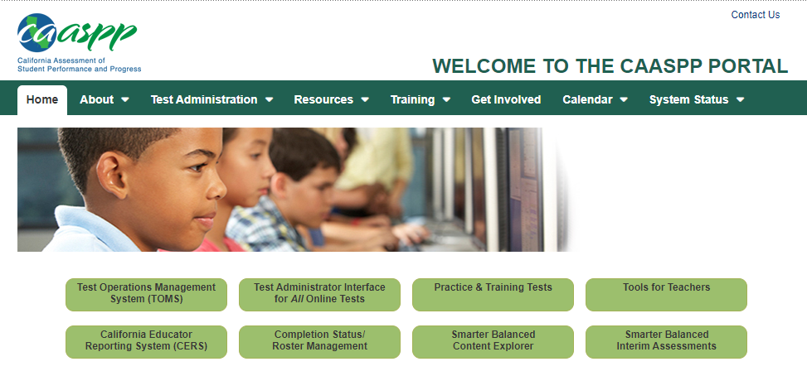

Figure 1. TOMS button on CAASPP website

1. This will open the TOMS Logonweb page (figure 2).

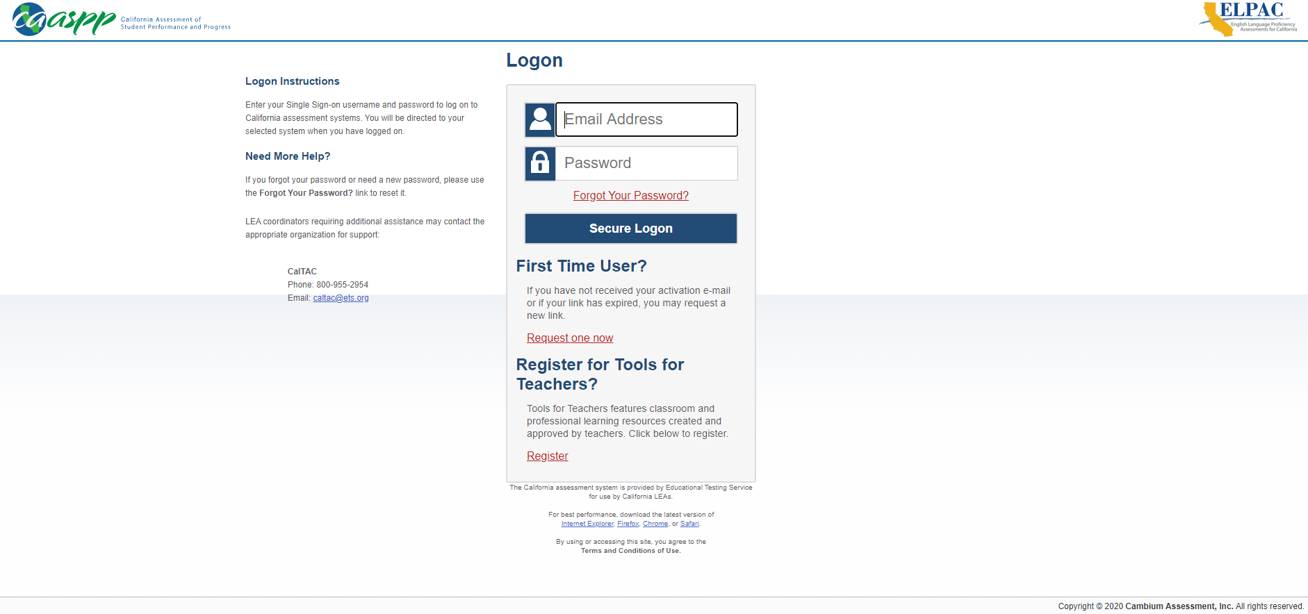

Figure 2. TOMS Logon web page

1. Enter email address and password (figure 2).
2. Select the[**Secure Logon**]button:
   1. If the logon credentials are correct, users are directed to the CERS home page.
   2. If logon credentials are incorrect, a notification appears. Users should contact the administrator if difficulties continue.

**Note:** If needed, to reset a password, select the [**Forgot Your Password?**] link.



1. The user may be prompted to enter a verification code: The two-step verification process is initiated the first time a user logs on to TOMS using a new device or browser. An email is sent to the user from [ca-assessments@ets.org](mailto:ca-assessments@ets.org) with the required code, which is valid for 15 minutes.
2. This will open up the TOMS landing page where users will be prompted to select a role for the session (figure 3).
3. Once a role is selected for the current session, select the[**OK**] button (figure 3).

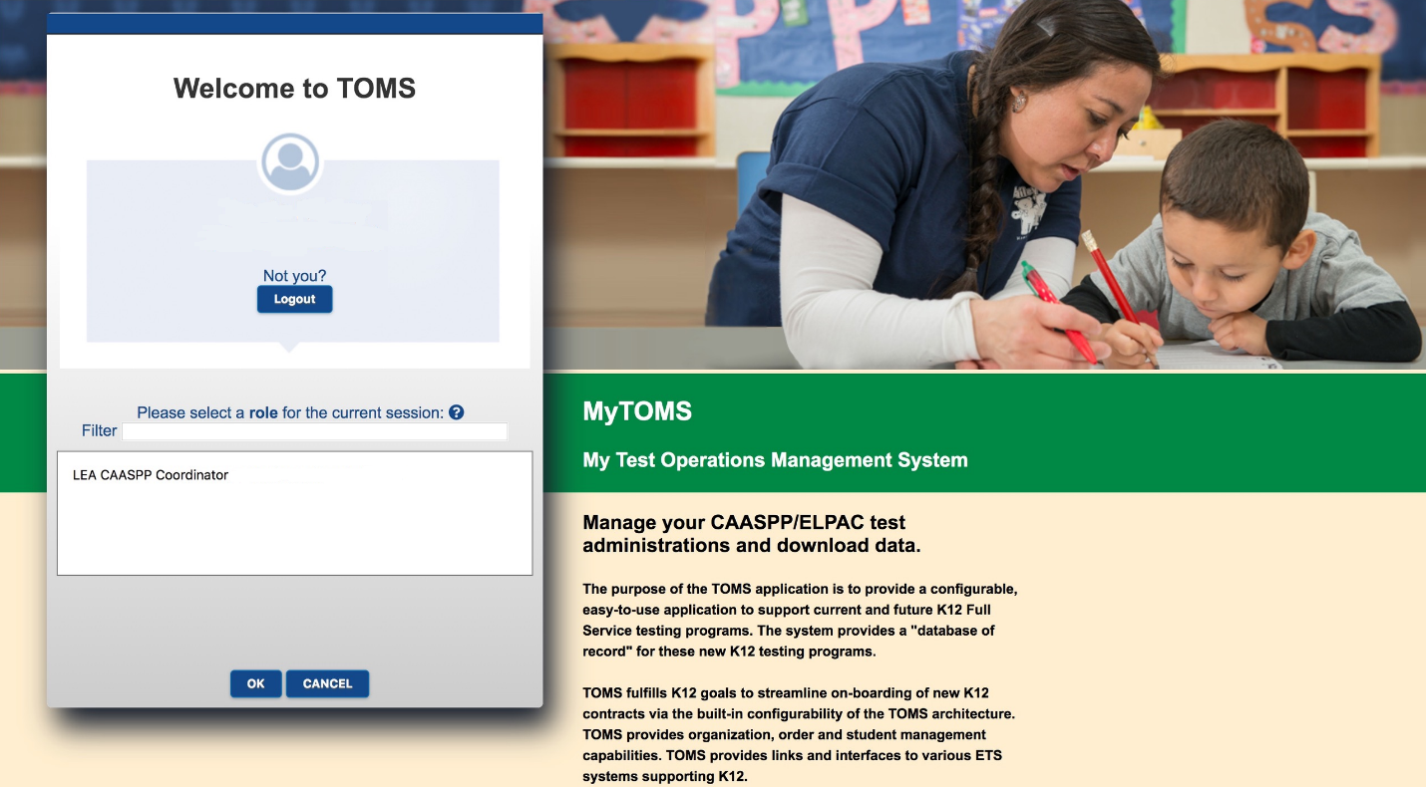

Figure 3. TOMS landing page

1. This will open up the TOMS home page (figure 4).
2. Select the [**Links**] tab at the top (figure 4).

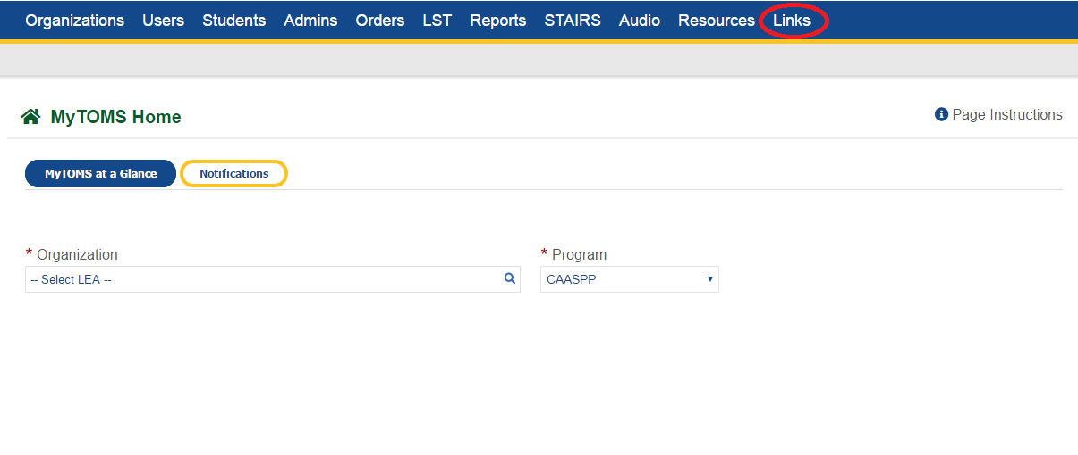

Figure 4. TOMS home page

1. Select the [California Educator Reporting System (CERS)] link (figure 5) which will take the user to CERS.

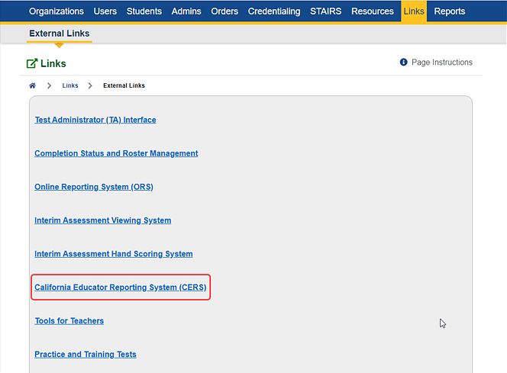Figure 5. CERS link

### Logging Off

Users may log off by using the following steps:

1. Select the Name menu in the corner (figure 6).
2. Select the Logout menu item (figure 6).

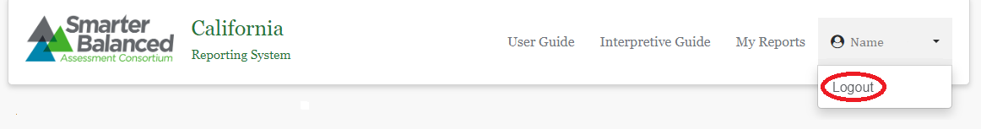

Figure 6. CERS Logout

1. This will return users to the TOMS home page.

## Understanding the User Interface

### Home Page

When users log on to the California Educator Reporting System (CERS), the users are directed to the home page. This page allows users to perform tasks permitted in their assigned roles (e.g., the home page for teachers with the Educator - Roster role does not display the *Administrator Tools* or *Search by School* features). Tasks initiated on the CERS home page include searching for assessment results, generating various reports, and performing administrative tasks, as shown next (figure 7).

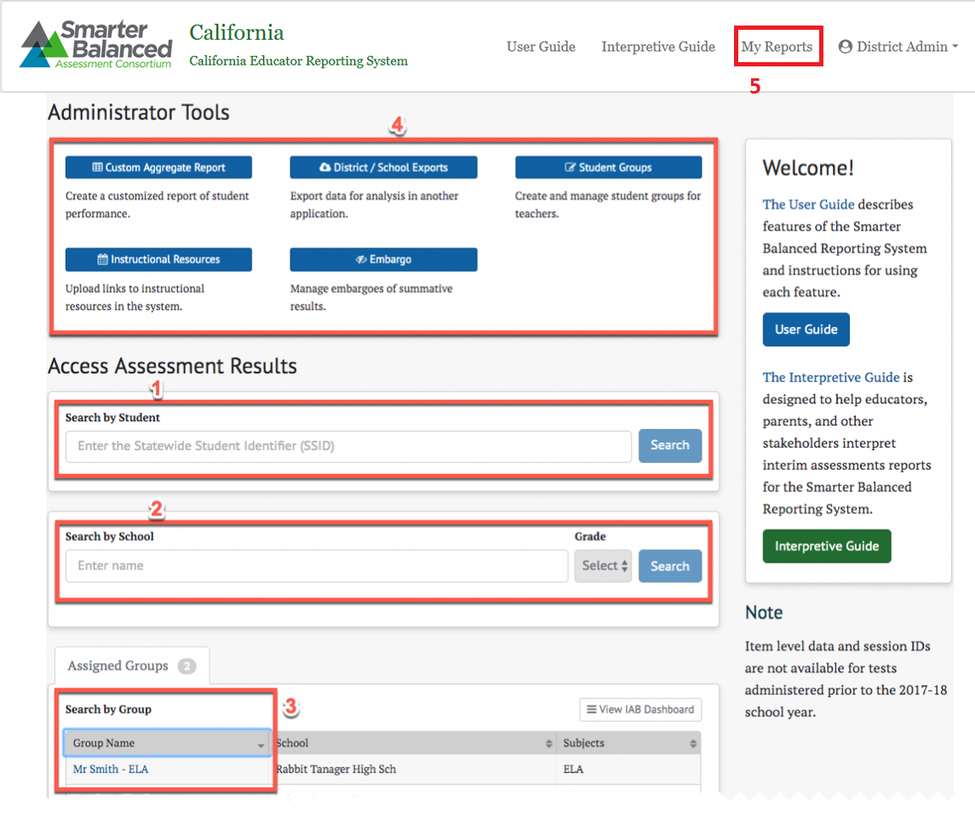

Figure 7. CERS Home Page with all tools

The elements of the home page are:

1. Search by Student***:*** Search for assessment results for a specific student. Refer to the Search by Student section for details.
2. Search by School***:*** Search for assessment results for students of a specific grade or multiple grades within one school or multiple schools. Refer to the Search by School section for details.
3. Search by Group***:*** View assessment results for a group of students. Refer to the Search by Group section for details.
4. Administrator Toolsare as follows:

Custom Aggregate Report***:*** Generate a customized report of student performance. Refer to the Custom Aggregate Reports section for details.

District / School Exports***:*** Export a CSV file of assessment results for one or more schools or districts. Refer to the District / School Exports section for details.

Student Groups***:*** Create and manage student groups for teachers. Refer to the Manage Student Groups section for details.

Instructional Resources***:*** Upload instructional resources in the system. Refer to the Manage Instructional Resources section for details.

Embargo***:*** Manage embargoes of summative results. Refer to the Manage Embargoed Results section for details.

1. My Reports**:** Allows access to all reports that have been generated by the user. Refer to the My Reports section for details.

**Note:** Only elements of the home page (and the entire system) that are relevant to the user’s roles will be available to a user.



### Navigation and Menus

Navigation within CERS is straightforward and primarily relies on hyperlinks to drill down into further detail. There are links across the top of the page to access this user guide and the *Interpretive Guide*, which is designed to help educators understand and effectively use the results of the Smarter Balanced summative and interim assessments.

When a user navigates to a page, a navigation path appears showing the current location within the system, as does an icon to navigate back to the home page. Each item in the path is separated by a slash (“/”), representing the path from the home page to the current page. In the following example, the user is on a screen presenting results for student responses. To return to the home page, the user can select the home page icon (shown in figure 8).

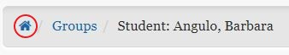

Figure 8. Home page icon

### General Tools

In addition to basic navigation, there are tools used throughout the site to search for, select, and display information.

#### Drop-down Lists

Drop-down lists are common in web applications. CERS uses multiple types of drop-down lists to present and organize information.

##### Basic Drop-down Lists

The basic drop-down list contains a short list of fixed information to allow easy and predictable navigation. Simply select to access the list (refer to figure 9).

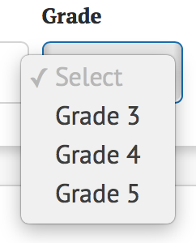

Figure 9. Sample drop-down list

##### Drop-down List with Search

Some drop-down lists may have hundreds or thousands of items. In those cases, a search field allows users to type to filter. These drop-down lists filter based on any match within the value, so a search term of “oak” would match “**Oak** Persimmon School,” “Elaenia **Oak** School,” and other schools with “oak” somewhere in the name (figure 10).

**Tip:** Typing at least three characters will provide better performance in narrowing search results.



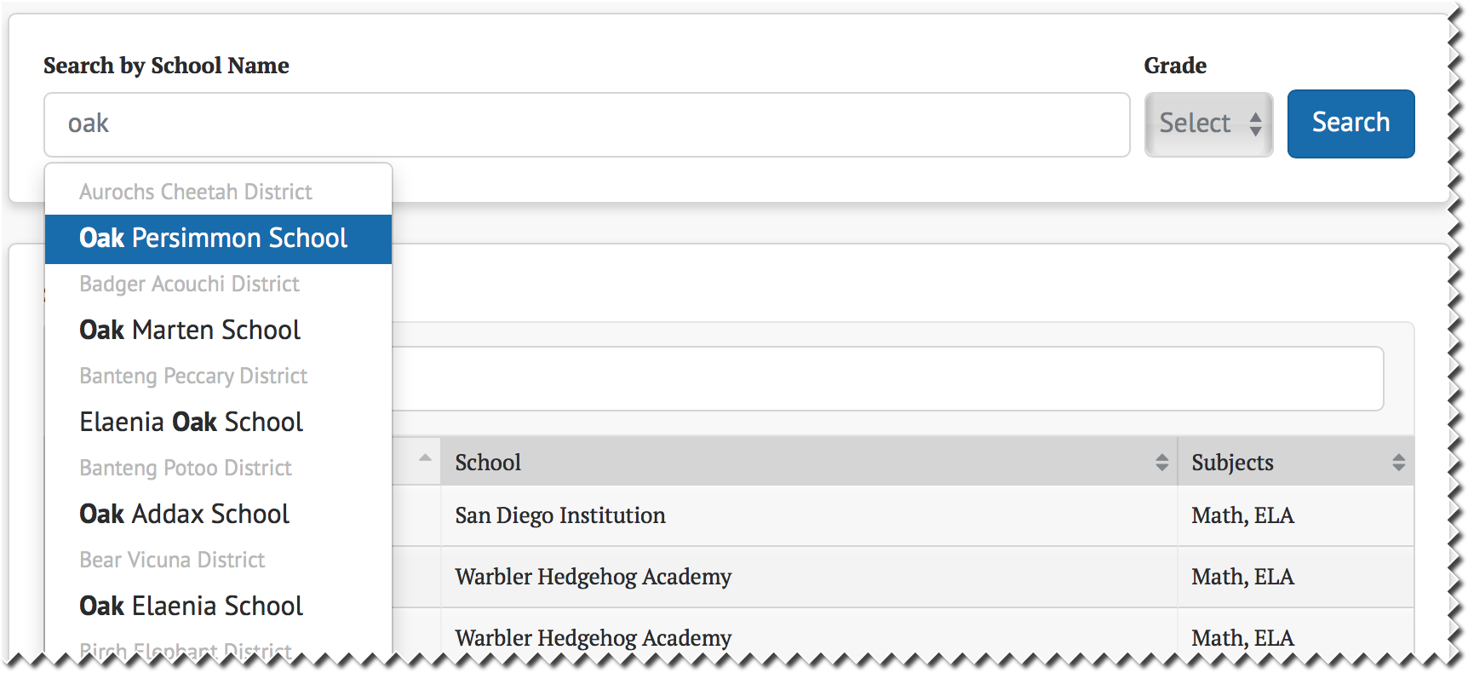

Figure 10. Sample drop-down list with search

##### Dependent Drop-down Lists

Dependent drop-down lists are two or more related drop-down lists where a value must be selected in the first drop-down list before the second drop-down list is selectable. In the following example (figure 11 and figure 12), the user must select a school name before selecting the grade.

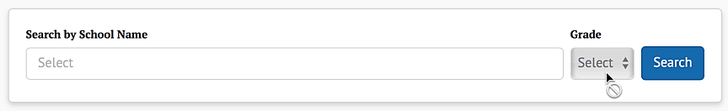

Figure 11. Sample dependent drop-down list

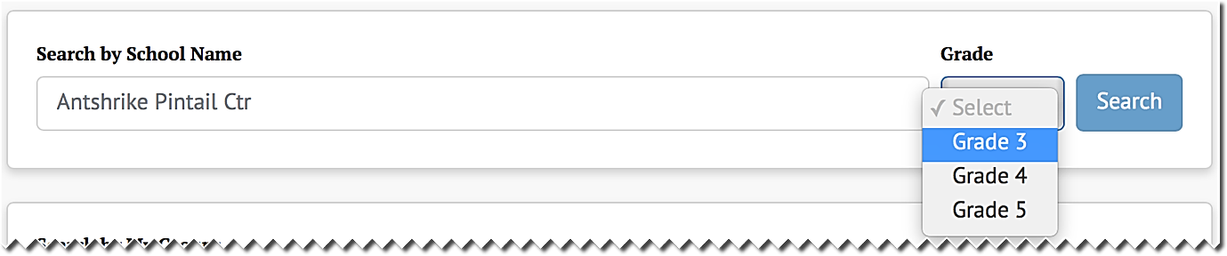

Figure 12. Sample dependent drop-down list with selectable list

#### Live Search

Some input fields include “live search,” in which matching results are displayed as the user types. In the following example (figure 13), the value entered retrieves matches anywhere within the group name.

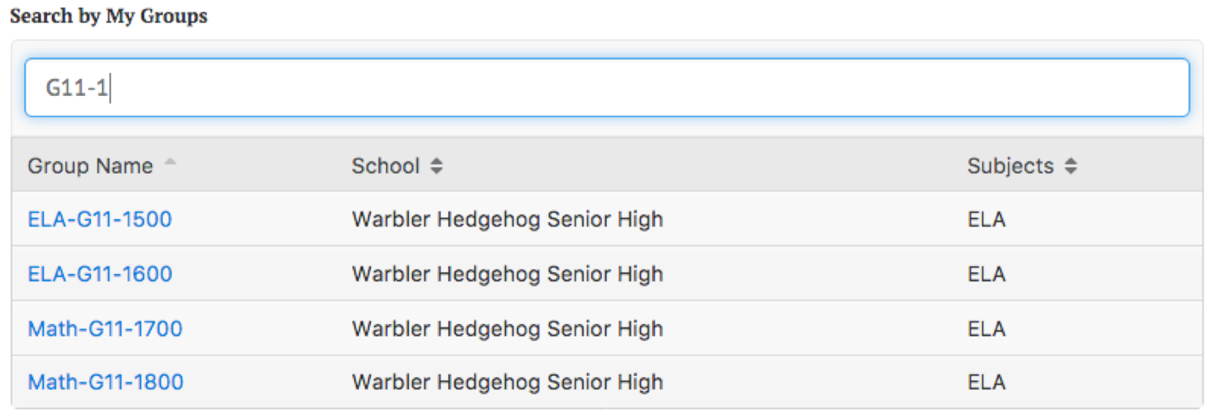

Figure 13. Sample live search

#### Exporting and Downloading

Users may export selected reports to a file in CSV format by selecting the [Export CSV] button (figure 14).

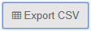

Figure 14. [Export CSV] button

Some screens in the application allow users to download reports. From the **My Reports**page, pictured in figure 15, selecting the Download Report Data menu option for a report name will download the report to the user’s computer.

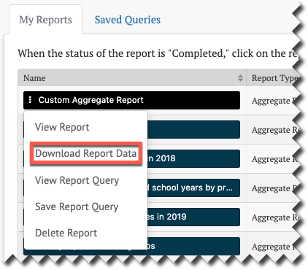

Figure 15. Download Report Data option

The location of exported and downloaded files is dependent on the web browser used to access CERS. Please refer to the web browser’s user guide for more information.

#### Context Menus

Context menus provide additional options for a button or icon. For example, when users select the[Student Reports]button, a context menu pops up with the ability to filter by School Year and sort by one of the Sort Order drop-down list values (figure 16).

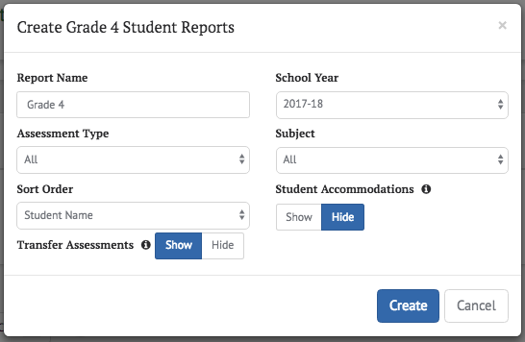

Figure 16. Sample context menu

When users select the [**Context Menu**] three-dot icon [] next to a student’s name, a small context menu pops up with additional links specific to that student (figure 17).

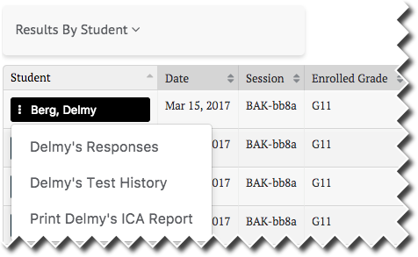

Figure 17. Sample context menu with drop-down list options shown

#### Column Ordering

Any tabular data containing columns that can be reordered by the user will have a column ordering control. This allows the user to move any selected column left or right, to reorder the columns as desired. Examples are shown in figure 18 and 19:

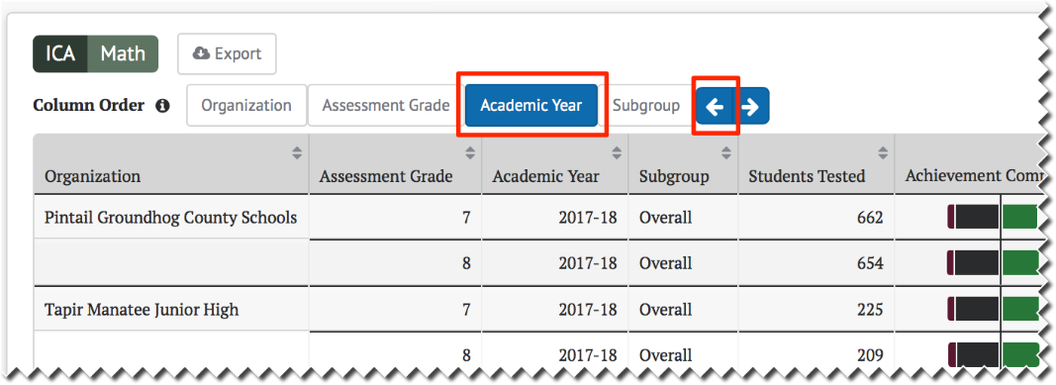

Figure 18. Column ordering control

If the user selects the [**Academic Year**] button and then selects the left arrow twice, the tabular data will appear as shown in figure 19:

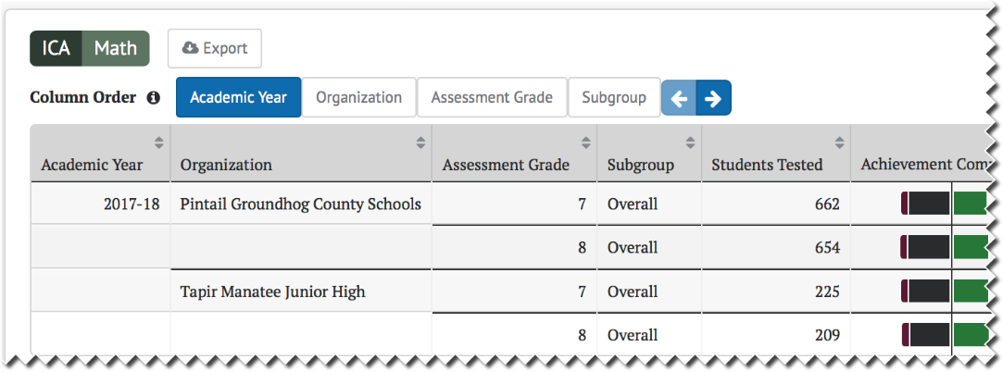

Figure 19. Column ordering control with change shown

Columns can also be reordered by simply dragging and dropping them with the mouse (select the column, hold, drag, and release).

#### Sorting

Tabular data are presented with column headers, and any sortable column will display up and down arrows. Select a column name to sort by that column and select it again to reverse the sort order. The currently sorted column and direction are shown in a lighter gray color. In the following example, figure 20, the results are sorted in ascending order by the students’ last names.

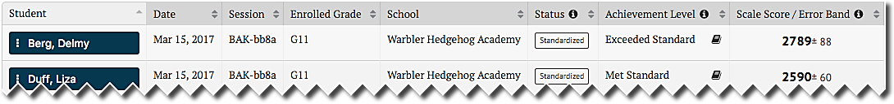

Figure 20. Column sorted in ascending order

#### Expanding and Collapsing

Additional up and down arrow icons are provided to show or expand, and hide or collapse, results (figure 21). These icons are displayed when a page contains information that might either be shown or hidden by default. For example, selecting the applicable icon with text (e.g., [**Expand All**]) will expand all results for all hidden items. Selecting the icon with the arrow only will expand or collapse that item only.

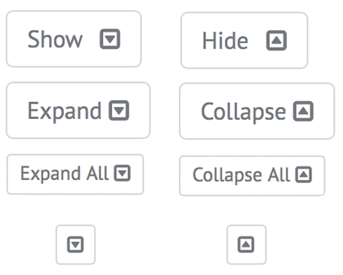

Figure 21. [Expand] and [Collapse] arrow icons

#### Toggle Buttons

Some values and data types can be displayed in different formats and view preferences. For these content types, there is a display toggle button for each option. Select the button associated with the preferred format or view preference. In the following examples shown in figure 22, the currently selected value is shown with either a gray background or blue highlight.

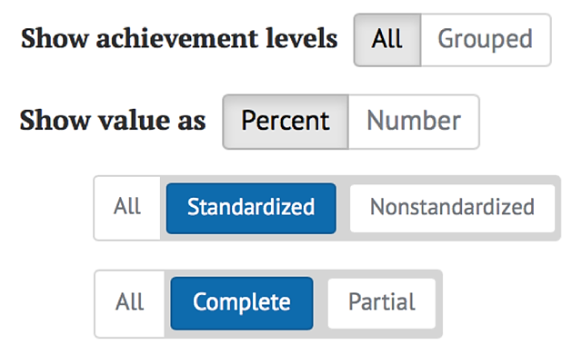

Figure 22. Sample toggle buttons

#### Advanced Filters

Test results have an advanced filtering capability that uses a variant of toggle buttons to allow users to select what to display in a report. As with toggle buttons, select the value to display; selected values are shown with a blue background (figure 23).

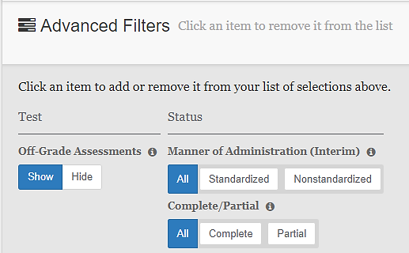

Figure 23. Sample advanced filter

#### Buttons

Selectable buttons may appear in different colors, depending on the button’s purpose (for example, buttons that generate reports and access instructional resources appear green). Typical buttons have a blue background and send or retrieve information when selected. If required information is missing, the button will be disabled, in which case it will not be selectable and a gray circle with a line will appear when attempting to select the button. To enable the button, provide the required information in the associated text field(s) or drop-down list(s). An example is shown in figure 24.

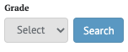

Figure 24. Sample selectable button

#### [Add] and [Remove] Icons

Elements with a [**Remove**] “x” icon[]can be removed by selecting the icon. When it is possible to add elements to a list, the [**Add**] plus sign icon [] will appear next to the list. Select the icon to add a new element to the list. Example icons are shown in figure 25.



Figure 25. Sample [Add] and [Remove] Icons

#### Informational Icons

Whenever an [Informational] lowercase-*i* icon[] is displayed, users can select it to read an explanation of the term it accompanies (figure 26). For example, when selecting the icon next to a table column, a pop-up bubble displays additional information.

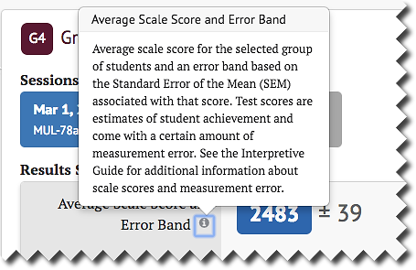

Figure 26. Sample informational icon

## Reporting Features in Detail

### Accessing Interim and Summative Assessment Results

There are several tools available to quickly search for interim and summative assessment results by school, student, or group. Depending on the user’s permissions (refer to User Roles and Permissions), one or more of these tools will be available on the *Assessment Results* home page.

#### Search by Student

If user permissions allow, the Search by Student panel (figure 27) will appear on the home page. Users can quickly search for a specific student using the Statewide Student Identifier (SSID).

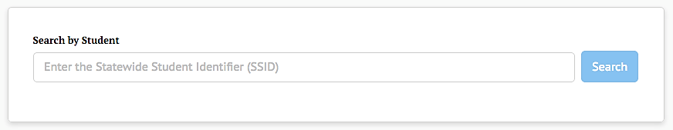

Figure 27. Search by Student panel

1. Type the student’s SSID into the box. The full SSID must be entered to search for a student.
2. Select the[Search]button (or press [**Enter**] on the keyboard).
3. If the SSID matches a student record with available assessment results and the user has permission to view that student’s information, the Student Test History Report page will be shown (figure 28).

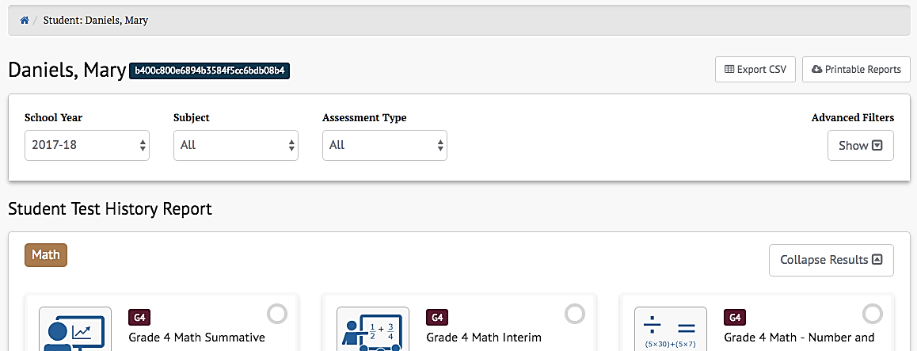

Figure 28. *Student Test History Report* page

1. If the SSID does not yield test results, either the user does not have permission to view that student’s information or there are no test results available for the student. A message will be displayed (figure 29).

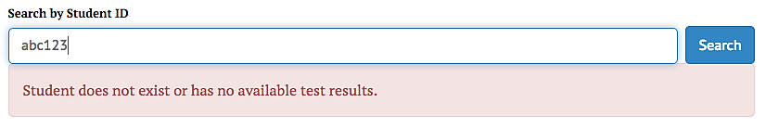

Figure 29. Search by Student message when results are not found

#### Student Test History Report

Once a student has been selected by SSID, the Student Test History Report page is displayed for that student, as shown in figure 30. This view will display all types of assessments.

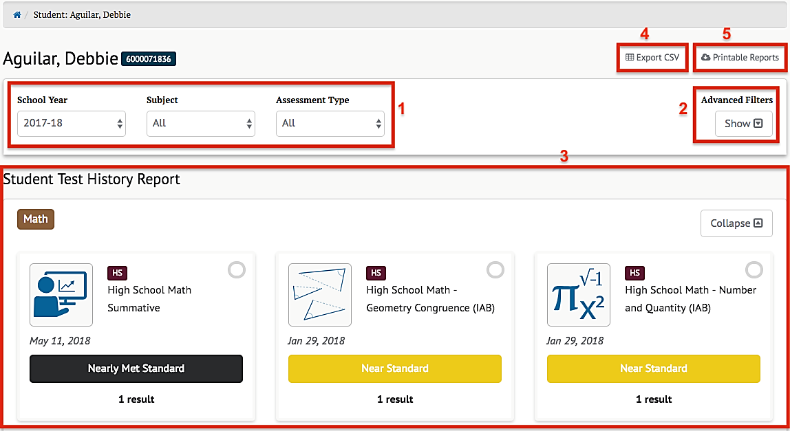

Figure 30. Sample Student Test History Report

In addition to identifying the selected student and the student’s SSID, the Student Test History Report page includes the following elements:

1. Selectors to choose which school years and subject to display, and a selector for all of the years and all of the subjects for which assessment results exist for the student
2. The [**Advanced Filters**] selector that shows or hides a filter panel to more precisely select which assessment results to view (Refer to the next section for a description of the Advanced Filters panel.)
3. The assessments that match the school year, content area, assessment type, and Advanced Filters settings
4. A button to export all of the student’s test history to a comma-separated value (CSV) file for download
5. A button to select and download a printable report in PDF format

##### Advanced Filters

The Advanced Filters panel (element 2 of figure 31, as illustrated in the Student Test History Report section) allows users to filter the assessment results to view only selected types of assessments.

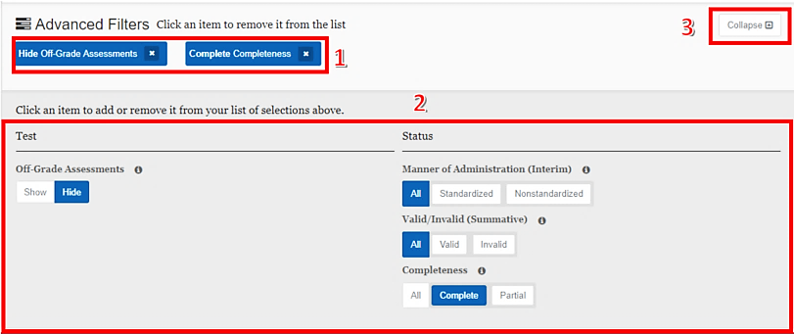

Figure 31. *Advanced Filters* panel

The elements available in the Advanced Filters panel are listed next. Changes to the filter criteria immediately modify the list of assessment results displayed.

1. Currently selected filters: selecting the [**Remove**]“x” icon []will remove the filter.
2. Assessment filters include the following:
3. *Off-Grade Assessments* shows results for all assessments regardless of whether the test taker’s enrolled grade matches the assessment grade or hides results when the enrolled grade and assessment grade do not match.
4. *Manner of Administration*, for interim assessments, indicates how the test was administered in terms of protocols and security procedures (Standardized or Nonstandardized).
5. *Valid/Invalid*, for summative assessments, indicates that a test is noted as invalid if an appeal was submitted to invalidate the test because of a test irregularity or breach (not shown).
6. *Completeness* indicates whether the test taker provided an answer for every test item.
7. A [**Collapse**] toggle collapses the bottom half of the panel, leaving only the selected filters displayed. This toggle becomes an [**Expand**] toggle when the panel is collapsed; it reopens the assessment filters panel.

**Note:** The Valid/Invalid filter is shown only when the available assessment results include any summative assessments. Similarly, the Manner of Administration filter would be enabled only if interim (Interim Assessment Block [IAB] or Interim Comprehensive Assessment [ICA]) results were available.



##### Printable Reports

The [Printable Reports] button (element 5 figure 30, as illustrated in the Student Test History Report section) opens a pop-up menu that allows users to generate and download a PDF report of student assessment results, as shown in figure 32.

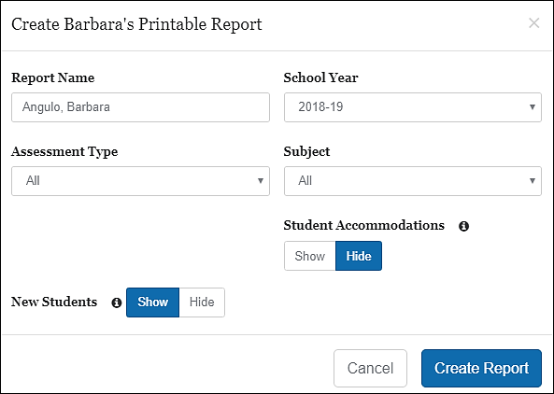

Figure 32. Printable Reports pop-up menu

The selections available for Assessment Type**,** Subject**,** and School Year are limited by system configuration. Not all content areas support printable reports, so those will not appear in the *Subject* drop-down.

**Note:** If a student has assessment entries from more than one school in a single school year, CERS identifies that individual as a new student. Users can hide assessments from previous schools by selecting the Hide New Students option when generating a report.



The report’s name defaults to the student’s name, but can be modified to define the report more clearly, if preferred. The New Students option may be selected to either show or not show any assessments from previous schools, if the student changed schools during the school year. The Student Accommodations option may be selected to either show or not show any accommodations made available to the student during testing.

**Note:** This feature does not include designated supports, such as pop**-**up glossaries, at this time.



Selecting the [Create Report]button will create the report for the selections in the pop-up menu.

##### Export CSV

The[Export CSV] button (element 4 figure 30, as illustrated in the Student Test History Report section) generates a CSV file for download containing all of the student’s test history for the selected school year and subject. An example of this file opened in Microsoft Excel is shown in figure 33.

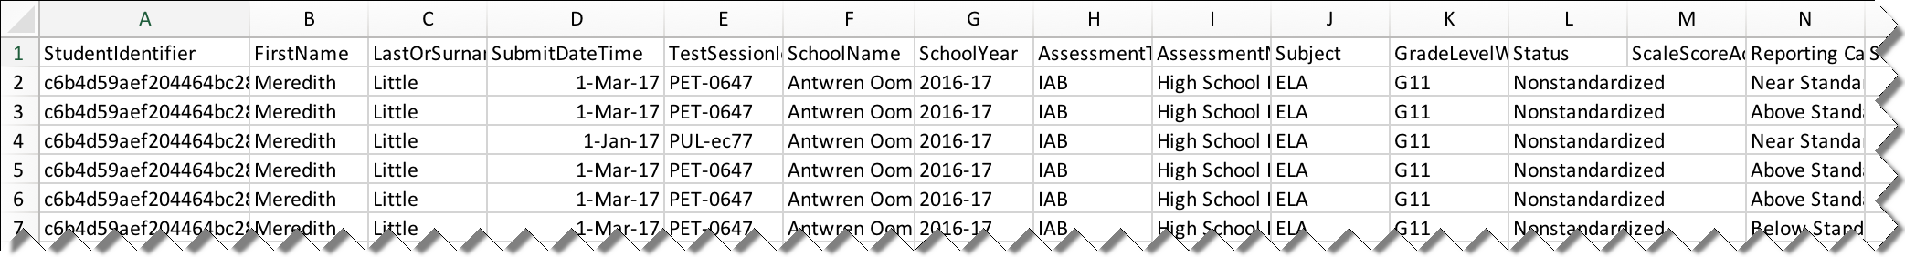

Figure 33. CSV file opened in Microsoft Excel

##### Student Test History Report Results

The Student Test History Report results (element 3 figure 30, as illustrated in the Student Test History Report section) are displayed in a dashboard format with each assessment that matches the selectors and advanced filters appearing as a separate card. A sample card is pictured in figure 34.

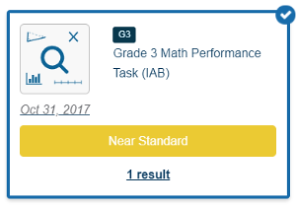

Figure 34. Student Test History Report results card

Each card contains

* an icon representing the type of assessment;
* the date the assessment was administered;
* the name of the assessment; and
* the student’s achievement level or reporting category for this assessment.

Selecting anywhere within this card will cause a table of additional information to appear. Depending on the type of assessment chosen, this table will contain slightly different information. For IAB assessments, this table appears as it does in figure 35.

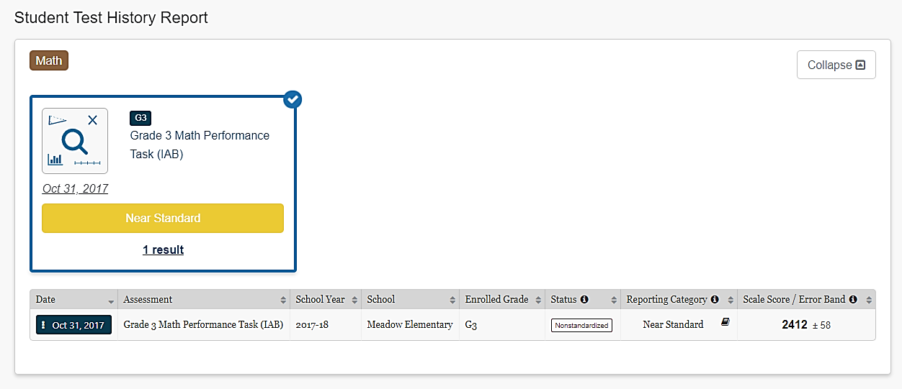

Figure 35. IAB Assessment table

In addition to the data previously described, this table displays the status (Standardized, Nonstandardized, or Partially Complete) and the Scale Score / Error Band of each result.

* The reporting category (Below Standard, Near Standard, Above Standard) is based on the minimum scale score for the “Met Standard” achievement level on the ICA and Smarter Balanced summative assessments. Refer to the *Interpretive Guide* for additional information.
* The student’s error band is based on the standard error of measurement (SEM) associated with the score.

Selecting the date with the [**Context Menu**] three-dot icon [] brings up the Student Test History Report Details Menu.

For ICAs and summative assessments, the table appears as it does in figure 36.

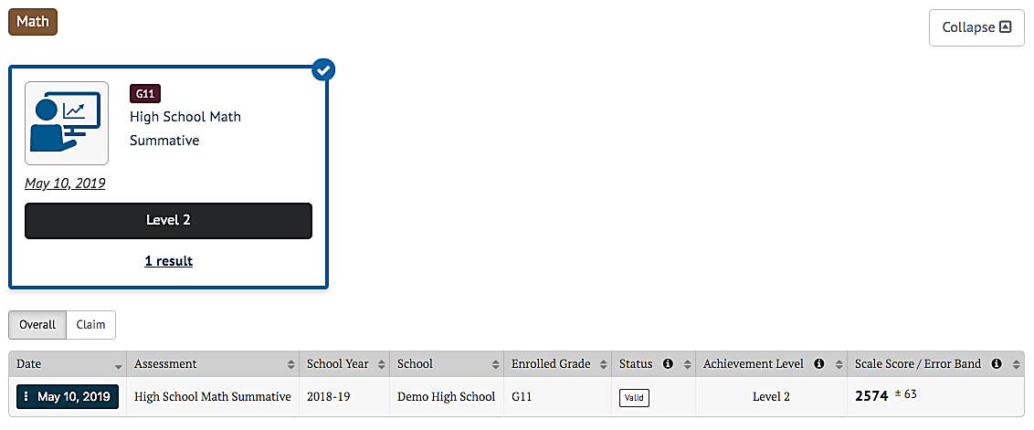

Figure 36. ICA and Summative Assessments Table

The *Overall* view of this table is similar to the IAB table, but includes the student’s achievement or performance level on the test based on the scale score.

The table also includes buttons to toggle the scores between the default *Overall* view and, if available Composite, and Claim scores. Selecting the [Claim]or **[Domain]** button changes the view to show student’s scores on the various claims or domains assessed, as shown in figure 37.

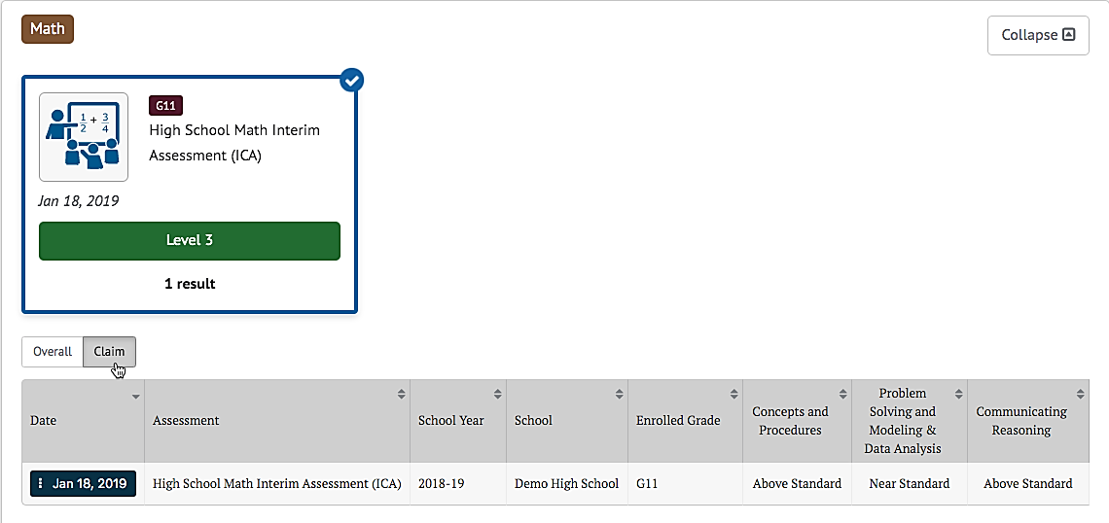

Figure 37. Overall and Claim Level Toggles for Interim and Summative Assessments

**Note:** Some assessments may use content-area-specific labels for scores. For example, English Language Proficiency Assessments for California labels *claims* as *domains*.



For the selected ICA assessment in the previous image, claim scores are provided for “Concepts and Procedures,” “Problem Solving and Modeling & Data Analysis,” and “Communicating Reasoning.” Claim scores are reported as Below Standard, Near Standard, and Above Standard. Refer to the *Interpretive Guide* for additional information. Selecting the [Overall] button returns to the default Overall view.

Selecting the date with the three-dot [] icon brings up the Student Test History Report Details Menu.

##### *Student Test History Report Details* Menu

Each row in the Student Test History Report includes a context menu that provides access to additional information, as shown in figure 38.

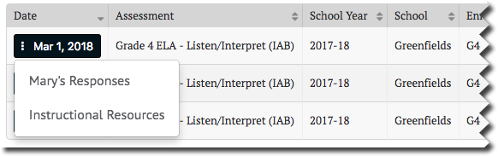

Figure 38. Student History Report context menu

For all interim assessments, this menu gives the user direct access to the student’s item responses (refer to the Student Responses section) for the selected assessment. The menu also includes a link to Instructional Resources such as the Smarter Balanced Connections Playlists in the Smarter Balanced Tools for Teachers or any Instructional Resources identified by the user’s state or LEA. For summative assessments, the menu is disabled.

##### Student Responses for Interims

The Student Responses table includes student responses to interim assessment items, as shown in figure 39.

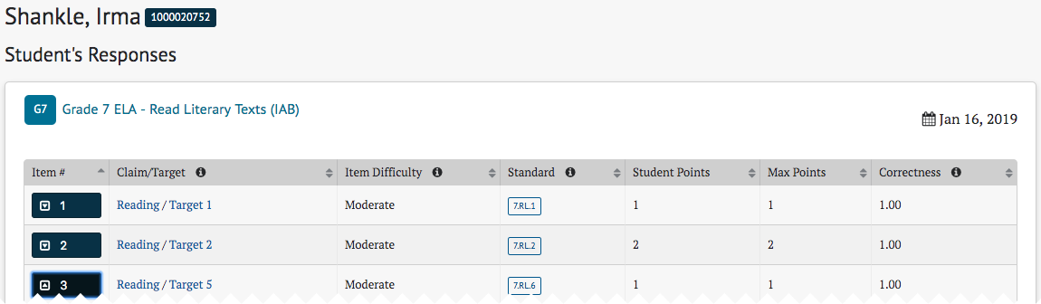

Figure 39. Student Responses table

Selecting an assessment item’s drop-down arrow [] icon expands the row to allow drill-down into the item to view additional details (figure 40).

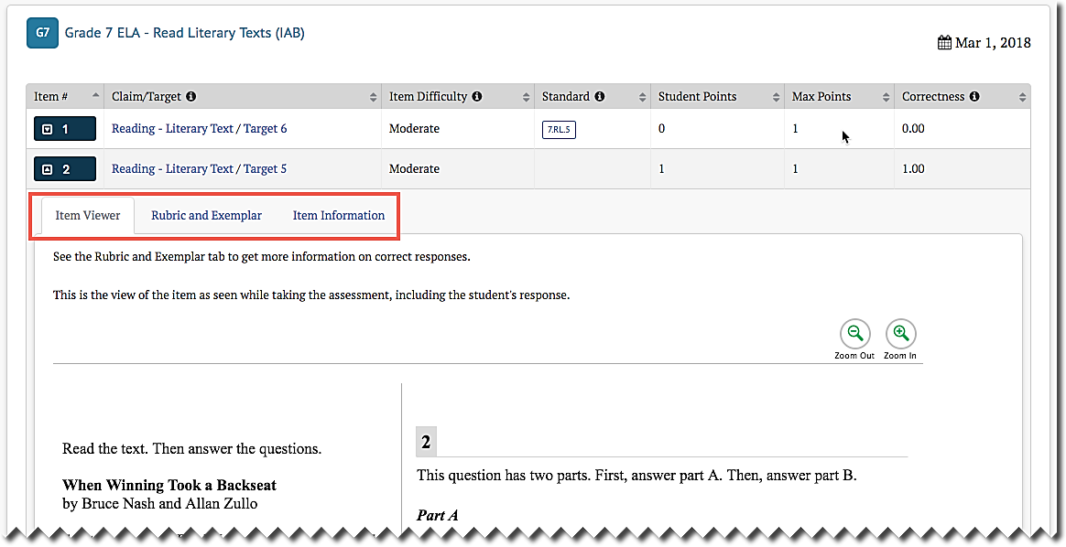

Figure 40. Student Responses table, expanded row

The [**Item Viewer**]tab displays the interim assessment item as it appeared on the test and the student’s response. The item number is shown at the top-left for the item being viewed. This view is read-only; there are no user-editable fields.

The [**Rubric and Exemplar**]tab functions as described in the Rubric and Exemplar section. The [**Item Information**]tab functions as described in the Item Information section.

#### Search by School

If permissions allow a user to access student results for an entire grade or multiple grades within one school or multiple schools, the Search by School panel will be available on the home page (figure 41). This panel allows quick access to assessment results by school and grade.

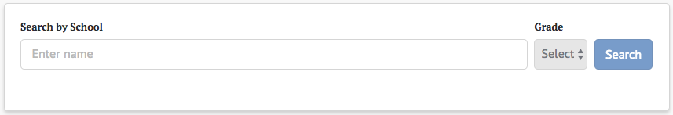

Figure 41. *Search by School* panel

To search for a school:

1. Select the search box to expand the Search by School name list. Schools are listed alphabetically by name and grouped by district.
2. Scroll through the full list to select a school or type the name of a school in the search box to find a specific school. As a user types, the list of schools accessible to the user (depending upon granted access) will be filtered to only show school names that have matching text anywhere in the name, as shown in figure 42.

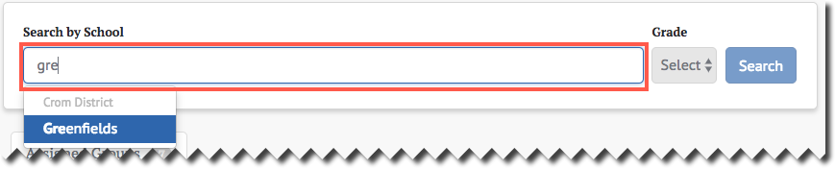

Figure 42. *Search by School* search

1. Choose the name of a school to select it.
2. If results are available for more than one grade at the school, select the desired grade using the Grade drop-down, as shown in figure 43. If only one grade is available, it will be selected.

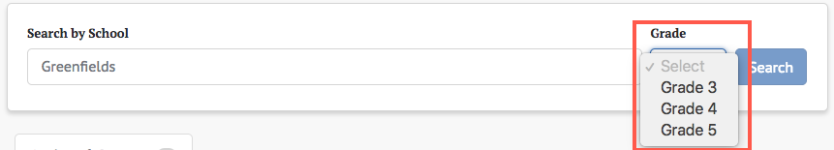

Figure 43. Search by *Grade* drop-down list

1. Select the [Search] button to search for assessment results for the selected school and grade.
2. If results are available, the default assessment results will be shown.
3. If no results are available, a message will be displayed on the assessment results page, as shown in figure 44.



Figure 44. Search by school “no results” message

#### Student Results by School and Grade

Selecting a school and grade for which assessment results exist displays the results page. Figure 45 shows the top panel on that page.

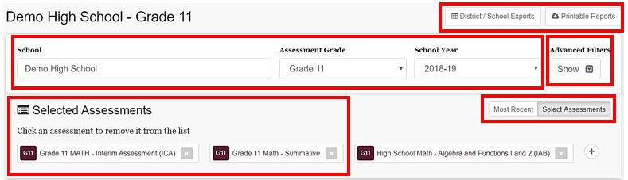

**5**

**3**

**4**

**2**

**1**

Figure 45. Results by School and Grade panel

This panel allows users to select the specific assessment results the users want to view by:

1. changing the school, assessment grade, or school year from which to select assessments;
2. showing or hiding the Advanced Filters panel to more precisely select the results to view;
3. selecting one or more assessments for which to view results;
4. toggling between only the most recent assessments or the selected assessments; and
5. generating and downloading student assessment results reports and test history results by an entire district or filtered by school(s).

#### Student Results Advanced Filters

The Advanced Filters panel (figure 46) allows users to filter the assessment results to view only selected types of assessments or to view only students with selected demographics.

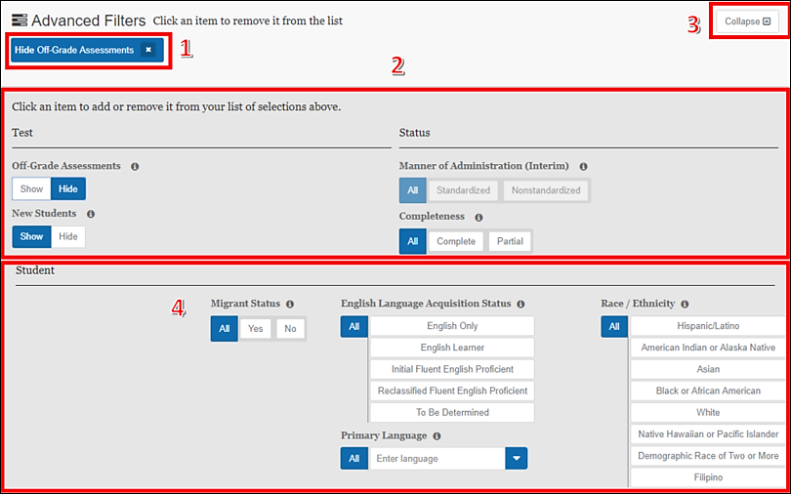

Figure 46. *Advanced Filters* panel

The elements available in the Advanced Filters panel are listed next. Changes to the filter criteria immediately modify the list of assessment results displayed. Elements one through three are the same as previously described in Advanced Filters.

1. Currently selected filters: selecting the [**Remove**][]icon will remove the filter. If the area is blank, no filters have been selected.
2. Assessment filters are shown in the lower portion of the panel.
3. Collapse toggle: This collapses the bottom half of the panel, leaving only the selected filters displayed.
4. Student filters: Depending on the system configuration, these may include: Race/Ethnicity, English Language Acquisition Status, (Primary) Language, and Migrant Status. Selecting values will reduce the list of students to just those that match those values. Selecting “All” for a field clears the filter for that field.

#### Selected Assessments

By default, the system displays the most recent assessment for the selected school, grade, and school year, and the [Most Recent] button is selected. Selecting the [Select Assessments] button or the [**Display**]plus icon[]opens a lower panel that displays all available assessments, as shown in figure 47.

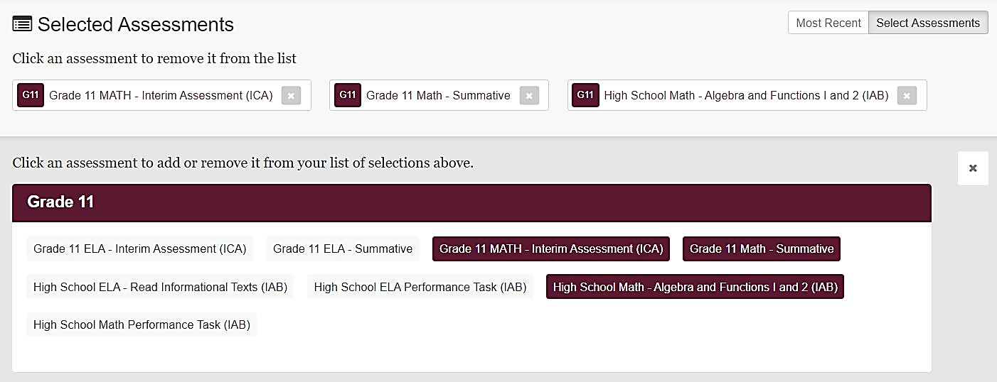

Figure 47. Panel displaying all assessments

Selecting an assessment in the lower panel adds it to the list of selected assessments in the upper panel and adds its results to the Results panel as shown in figure 48. Selecting a selected assessment de-selects it and removes its results.

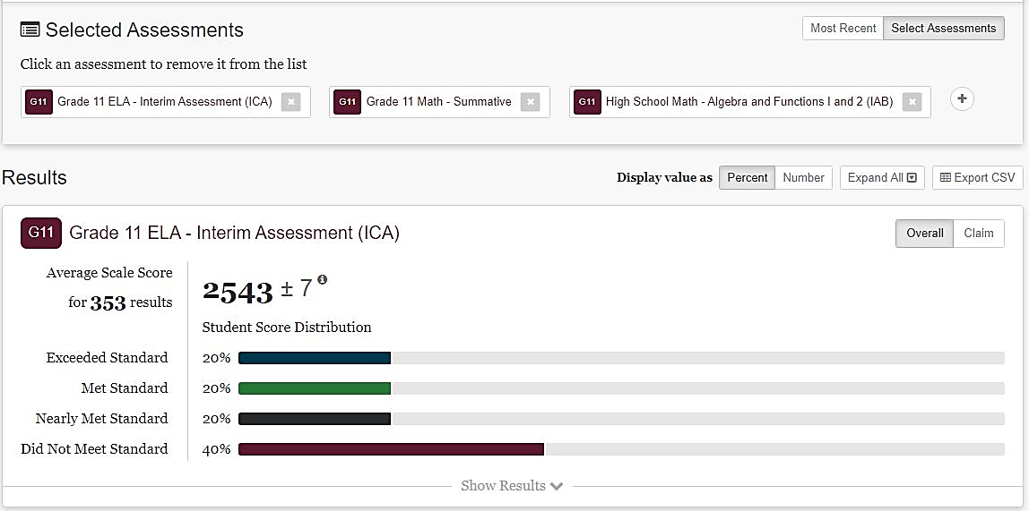

Figure 48. Selected Assessments results panel

#### Student Assessment Results Report

The [Printable Reports] button (element 5, as illustrated in the Student Results by School and Grade section) opens a pop-up menu that allows users to create a report of student assessment results for a group of students, as shown in figure 49.

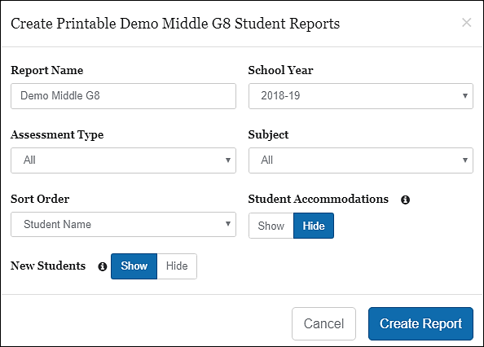

Figure 49. Printable Reports pop-up menu

The selections available for Assessment Type, Subject, and School Year are limited to the configuration of the system.

The report’s name defaults to the group’s name but can be modified to define the report more clearly if preferred. The New Students option may be selected to either show or hide any assessments students took at previous schools during the selected school year. The Student Accommodations option may be selected to either show or not show any accommodations offered to students during testing; this feature does not include designated supports such as pop-up glossaries.

Selecting the [Create Report]button will create the report for the selections in the pop-up menu.

#### Search by Group

The Search by Group panel (figure 50) on the home page displays a list of groups to which the current user has access. Selecting one of the group names in the list opens the Groups page for that group so the user can select and view assessments for the group.

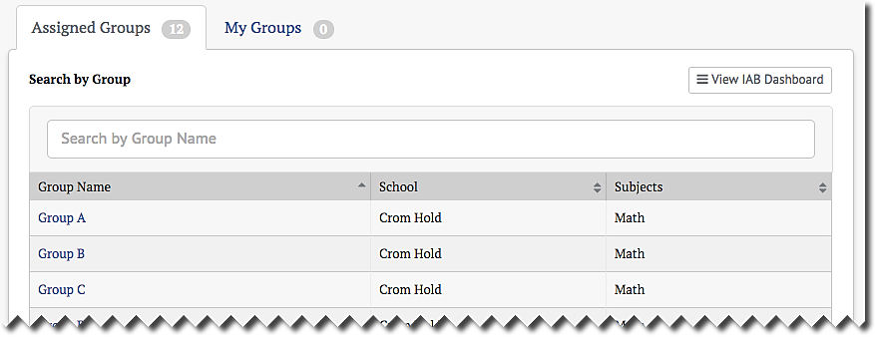

Figure 50. Search by Group panel

##### Filter by Group Name

If there are a large number of available groups, a live search box will appear above the list to assist in finding the desired group. The process is as follows:

1. Begin typing the name of a group in the Search by Group Name text box.
2. The list of groups shown will be automatically filtered to only show groups that match the entered characters.
3. Select the desired group from the filtered list.

##### No Groups Shown

A message will be shown if no matching groups are found. This could be because there are no assigned groups (figure 51) or because the search string does not match any of the assigned groups (figure 52). The displayed error messages are different in these two cases.

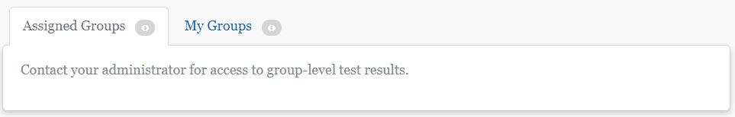

Figure 51. “No groups available to current user” message

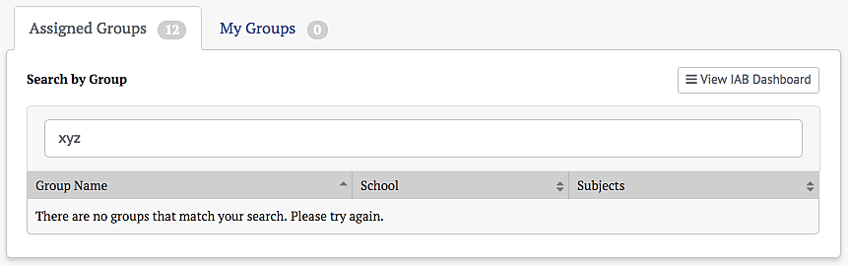

Figure 52. “No groups match search” message

##### Searching My Groups

Teachers may create customized groups of students based on the students assigned to them by an administrator in the [**Assigned Groups**]. The teacher-created groups will appear in a second tab called [**My Groups**], which is next to the[**Assigned Groups**] tab (figure 53). Search functionality for My Groups is identical to Assigned Groups. Refer to the next section for instructions on creating customized groups.

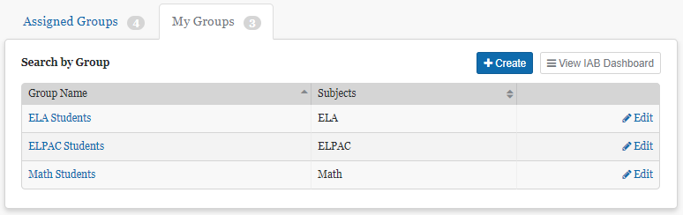

Figure 53. [My Groups] tab

##### Creating My Groups

Teachers can create customized groups of students selected from the Assigned Groups by selecting the[+Create] button on the My Groups tab panel. This will bring up a New Group definition screen (figure 54).

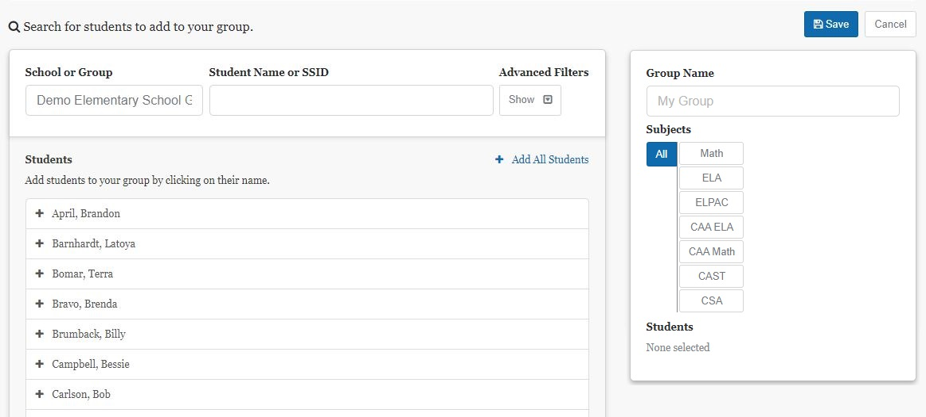

Figure 54. New Group definition screen

Take these steps to create the group.

1. Select a group from the Group entry box. Selecting this box will display a drop-down list of all assigned groups. Typing directly into the box will activate a live search to filter this list.
2. Select the group from which the new group will be created. The *Students* panel will be populated with the list of students in the selected group.
3. If necessary, filter the student list by entering characters into the Student Name or SSID box. It is also enabled for live search and will filter the student list by matching the entered characters.
4. Advanced Filters may also be used to filter the student list. Learn more about the use of these filters next.
5. Select students for the new group. The added students will appear in the *Students* list on the panel to the right of the page.
6. Repeat steps 1–5 for additional assigned groups. The new group may contain students from multiple assigned groups.
7. Remove any students accidentally added to the new group by selecting the students’ names in the new Student list in the panel to the right of the page. Select [x Remove All Students] to clear the list and start over.
8. Select[+ Add All Students] to add all of the students in the assigned group to the new group.
9. Name the new group by entering a name into the Group Name box in the right panel.
10. Select the tested subjects for the group using the [**Subjects**]buttons.
11. Select the [Save] button to create the new group or select the [Cancel] button to cancel creating a new group and return to the My Groups list.

Before saving, the right panel should appear similar to figure 55:

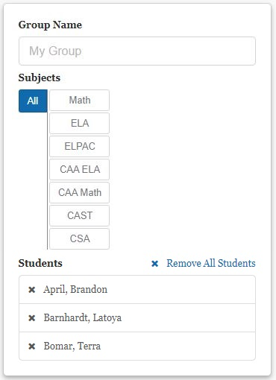

Figure 55. Completed New Group definition screen

After the new group is saved, it will be displayed in the list in the My Groups panel on the home page (figure 56).

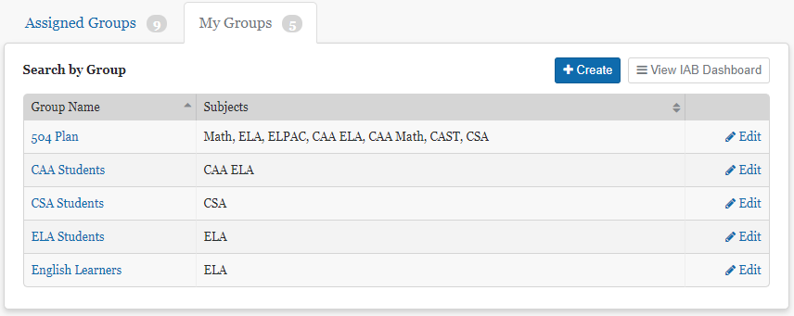

Figure 56. My Groups panel

A group may be edited by selecting [**Edit**] in its row. The edit screen will also contain a [Delete] button, which allows the user to delete the new group from the system.

**Caution:** The delete action is permanent and cannot be undone.



**Note:** If a user does not have any assigned groups, then it is not possible to create custom groups. In this case, the [+ Create] button is disabled. Contact administrator if no assigned groups are listed.



##### Using Advanced Filters

Advanced filters can ease the task of selecting students for the custom groups in My Groups. Selecting the [Show] button under Advanced Filters in the New Group page opens the filter controls (figure 56).

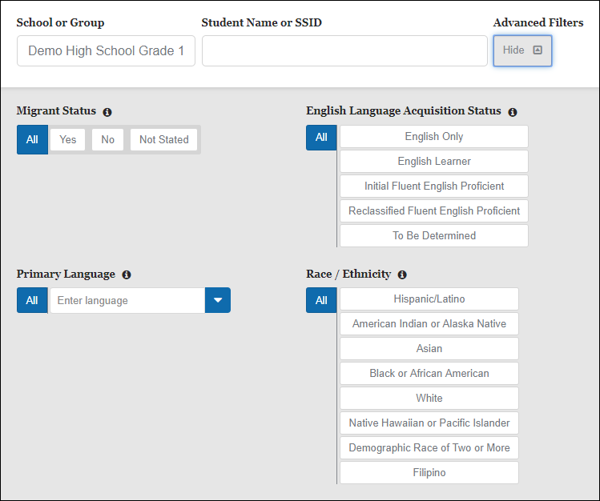

Figure 56. New Groups page advanced filters

These controls can be used to filter the list of students from the selected assigned group. Only the students that match the configured filters will be displayed. This makes it easier to identify and select students by subgroup. When filters are selected, the [Show/Hide] button displays a number indicating the number of configured filters. This number persists even when the Advanced Filters panel is toggled back to hidden.

**Note:** Filters only affect the list of students to be selected. The list of already selected students is not affected by adding or removing filters.



##### Select Group Name to View Results

Selecting a Group Name in the list (figure 57) takes users to the Groups page for that group. This is true whether the group being selected is one of the Assigned Groups or one of the customized groups from My Groups.

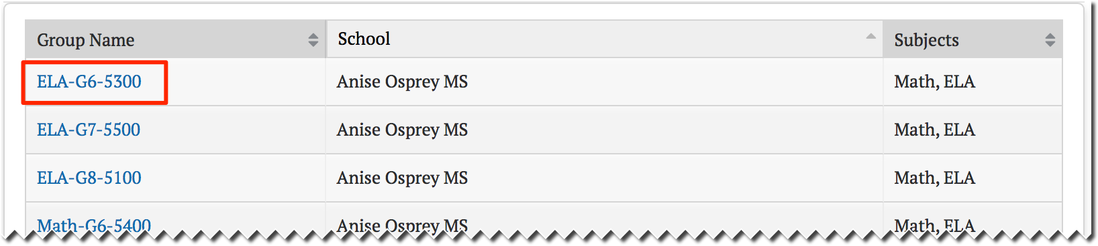

Figure 57. Group name for selection

### Student Group Assessment Results

Assessment results for student groups are accessed by selecting a group using the Search by Groups panel. Once a group has been selected, the results for that group are displayed. The way results are displayed varies by the type of assessment, but all results have the Groups panel as shown in figure 58.

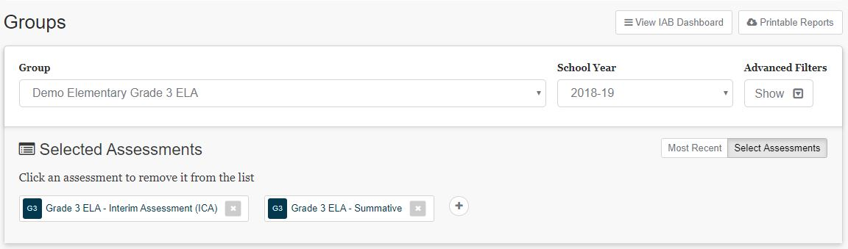

**2**

**5**

**1**

**4z**

**3**

Figure 58. *Groups* panel



**Note:** The [**District / School Exports**] button will not appear for teachers.

Use the Groups panel to:

1. Select a different student group or school year for which to view results;
2. Show or hide the Advanced Filters panel to precisely select which results to view;
3. Select the assessments for which to view results;
4. Toggle between viewing results for each student group’s most recent assessment and selecting specific assessments; and
5. By selecting a button, jump to the IAB Dashboard, export data for an LEA or school, or download PDF reports of assessment results for students in the selected group (refer to the IAB Dashboard and Student Assessment Results Report sections for details).

#### Selected Assessments

Selected Assessments works as described previously in Selected Assessments. Please refer to that section for details.

#### Assessment Results

The Results panel for an IAB is shown in figure 59. One Results panel will be displayed for each assessment that was selected in the Selected Assessments panel as described previously. The results panel can be used to view all assessments such as IAB, ICA, or summative.

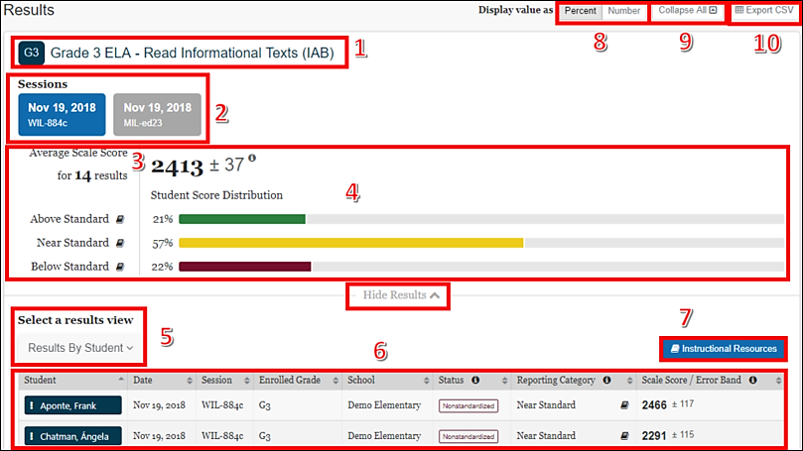

Figure 59. Results panel for an IAB

Each IAB Results panel displays the following information and elements:

1. The name of the assessment
2. The testing session(s) from which results are displayed

**Tip:** Users can select a testing session to include its results in the combined results shown in the Student Results table. Selecting it a second time removes the session from the results.



1. Results Summary

The average scale score for the selected group of students and the Standard Error of the Mean (SEM) associated with that score

The number of student test results from which the scores are calculated

**Note:** Test scores are estimates of student achievement and come with a certain amount of measurement error. Refer to the *Interpretive Guide* for additional information about scale scores and measurement error.



1. Student Score Distribution for the selected results
2. The Select a results view drop-down list, which offers the following options for display results:

* *Results By Student* (default view)
* *Results By Item* (for interim assessments only)
* *Key / Distractor Analysis* (for selected-response interim assessment items)
* *Writing Trait Scores* (for English language arts/literacy [ELA] performance tasks only)

1. The results, with sortable columns and additional information icons
2. The [Instructional Resources] button, which shows related instructional resources from the Tools for Teachers and the user’s state or LEA, if available
3. The Display value as a toggle, which shows the student score distribution in percentages of students or numbers of students in each reporting category
4. The [Collapse All]button, which hides the Results table for all the displayed assessments and toggles to an [Expand All] button, which displays the results again
5. The [Export CSV] button, which gives the option to download the results in CSV format
6. The [Hide Results] button, which toggles to a [Show Results] button, offers the same functionality as the [Collapse All] button explained in item 10, but only applies to a single assessment.

### Interim Assessment Results

#### IAB Results By Student

When the Results By Student option is active, the IAB results panel shows a table with the interim assessment results for each student. The table has sortable columns and additional information icons as shown in figure 60:

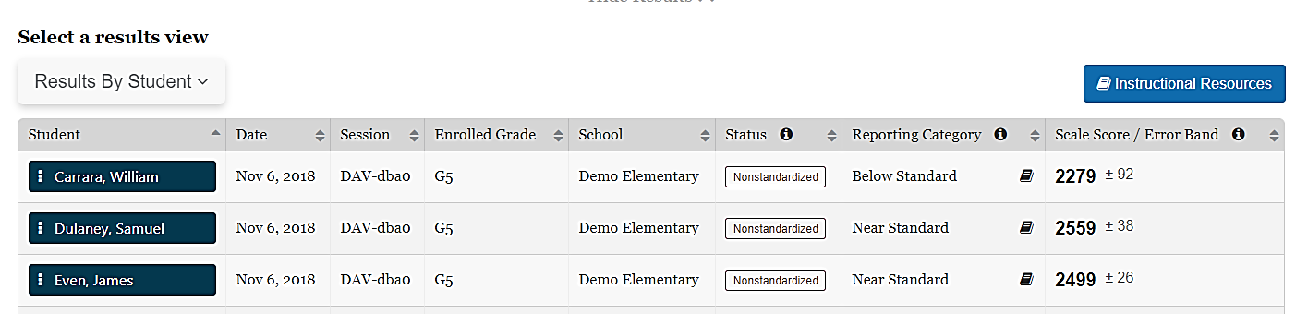

Figure 60. IAB Results By Student

The table includes the following information for each student:

* Student’s full name
* Date of assessment
* Test session
* Enrolled grade at the time of the assessment
* The school where the student was enrolled at the time of assessment
* The assessment status includes whether the assessment administration was Standardized or Nonstandardized, or if the assessment was marked Partial or Complete
* The score reporting category, which is Below Standard, Near Standard, or Above Standard
* A link, indicated with the [**Instructional Resources**] book icon [], to Instructional Resources shows available instructional resources from the Tools for Teachers and the user’s LEA as related to the IAB administered

**Note:** The performance standard is based on the minimum scale score for the "Met Standard" achievement level on the ICAs and Smarter Balanced summative assessments (the score that separates levels 2 and 3). Refer to the *Interpretive Guide* for more information on scale scores and reporting categories.



* The student’s scale score on the assessment and the error band based on the SEM associated with that student’s score

**Note:** The error band is included because test scores are estimates of student performance and achievement and come with a certain amount of measurement error. Refer to the *Interpretive Guide* for additional information.



* A [**Context Menu**] three-dot icon[]allows a user to access a pop-up menu that allows further selections of student details to be made (refer to the IAB Student Options section).

#### IAB Student Options

When the[**Context Menu**] three-dot icon [] next to a student’s name is selected, the *Student Options* pop-up menu, shown in figure 61, appears.

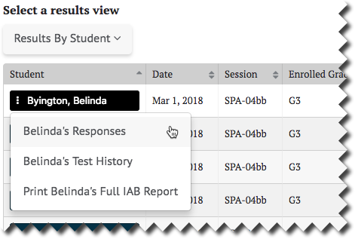

Figure 61. Student Options pop-up

The menu options are**:**

* Responses**:** This displays the student’s responses to each item on the assessment. Refer to the Student Responses section for details.
* Test History**:** This displays the test history of the student. Refer to the Student Test History Report section for details.
* Print Full IAB Report**:** This links to a printable Student Report in PDF format. The selections that are already known in the context of the IAB results, such as the *Assessment Type*, *Subject*, and *School Year* are auto-filled. Refer to the Printable Report section for details.

#### IAB Results By Item

When the Results By Item option is active, the IAB results panel shows a results table with an aggregate view of how the students performed on each item. The table has sortable columns and additional information icons as shown in figure 62:

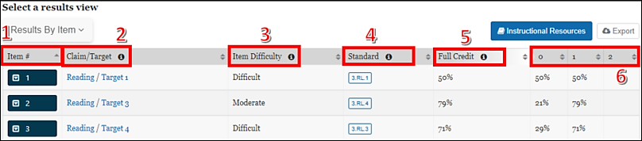

Figure 62. IAB Results By Item

The data shown in the Results By Item view indicates how the students performed overall on each assessment item, as described next.

1. Item #**:** the number of the item in the order it was presented to the student
2. Claim/Target**:** the topic area and particular knowledge and skills tested by the item

**Note:** Claims and targets are a way of classifying test content. The claim is the major topic area. For example, in English language arts, Reading is a claim. Within each claim, there are targets that describe the particular knowledge and skills that the test measures. Each target may encompass one or more standards from the Common Core State Standards. For more information, refer to the Smarter Balanced Content Explorer at [https://contentexplorer.smarterbalanced.org](https://contentexplorer.smarterbalanced.org/).



1. Item Difficulty**:** item difficulty (easy, moderate, or difficult) based on the difficulty of the item for students in a reference population (The reference population for an item consists of all the students who took the assessment the year the item was field-tested.)

**Note:** Refer to the *Interpretive Guide* for a description of the reference population and how the difficulty categories are derived.



1. Standard: Common Core State Standard(s) related to the item
2. Full Credit: the percentage or number of students in the selected group who earned the maximum number of points for the item
3. 0, 1, 2, … the percentage or number of students who earned each possible score-point level on the item

Users may sort by each of these categories of information to quickly identify items of interest. Additionally, an [Export] button is available to export the results of the report to a CSV file.

#### IAB Results By Item Details

Selecting an assessment item’s drop-down arrow [] icon expands the row to reveal additional details about that item, as shown in figure 63.

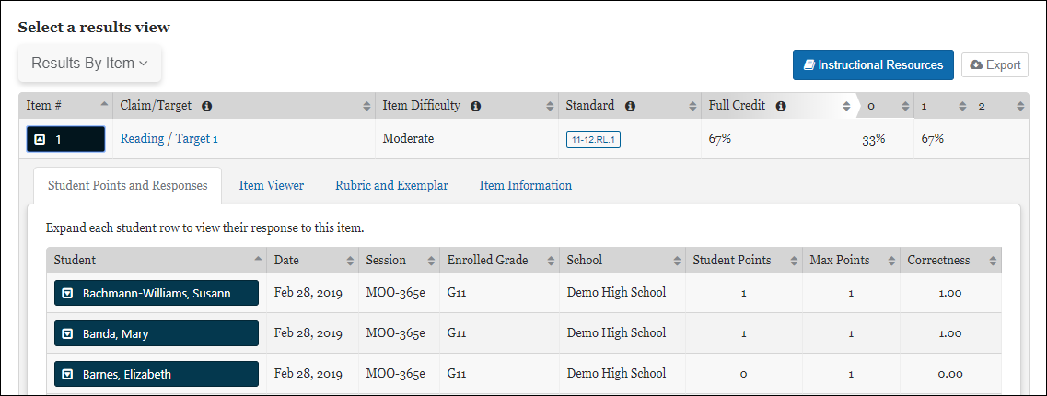

Figure 63. IAB Results By Item additional details

##### Student Points and Responses

The[**Student Points and Responses**]tab lists each of the students in the selected session(s) and the points earned by the student for each item, as previously shown. It displays each student’s name, test date and session, enrolled grade, and school. The report shows the number of points the student earned on the item, the maximum points available for the item, and the correctness of the student’s response, which is the ratio of the student’s points to the maximum points. For example, a student who earned 1 point out of a maximum of 2 would have a correctness value of 0.50.

Selecting the drop-down arrow [] icon next to a student’s name displays the assessment item the student viewed when the student took the assessment and the student’s response. The item number is shown at the top-left for the item being viewed. This view is read-only; there are no user-editable fields. An example is shown in figure 64.

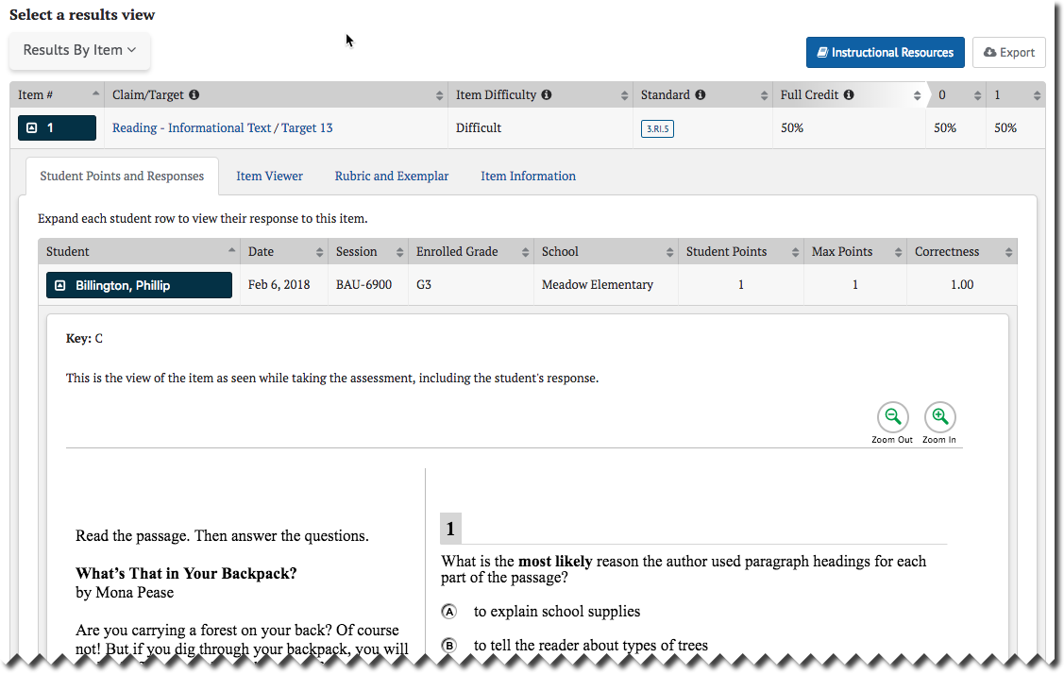

Figure 64. [Student Scores and Responses] tab

##### Item Viewer

The Item Viewer display shows the assessment item as it appeared on the test but does *not* show the student’s response. The item number is shown at the top-left for the item being viewed. This view is read-only; there are no user-editable fields. An example Item Viewer is shown in figure 65.

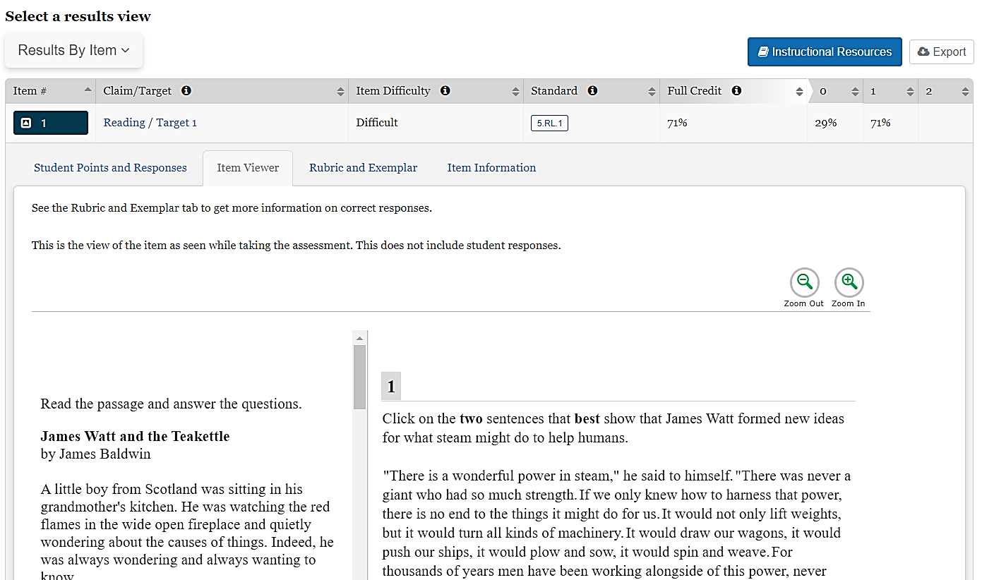

Figure 65. [Item Viewer] tab

##### Rubric and Exemplar

The Rubric and Exemplar view displays the answer key, or exemplar, and the rubric for the assessment item (figure 66).

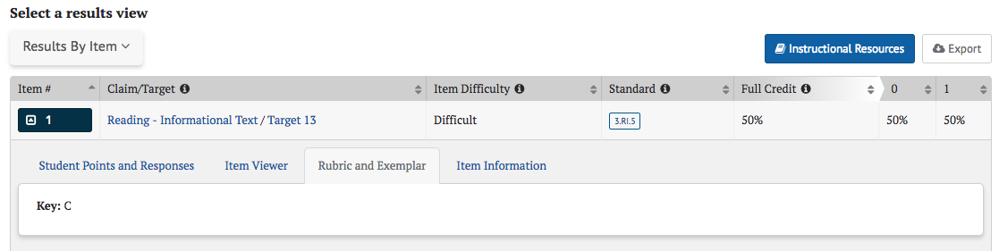

Figure 66. [Rubric and Exemplar] tab

The Exemplar provides the correct answer and, in some cases, multiple correct answers. For selected response test items (e.g., multiple-choice, multiple-select, or evidence-based selective response items), a Key (answer key) is shown.

The Rubric can also describe the point values associated with specific responses, as shown in figure 67.

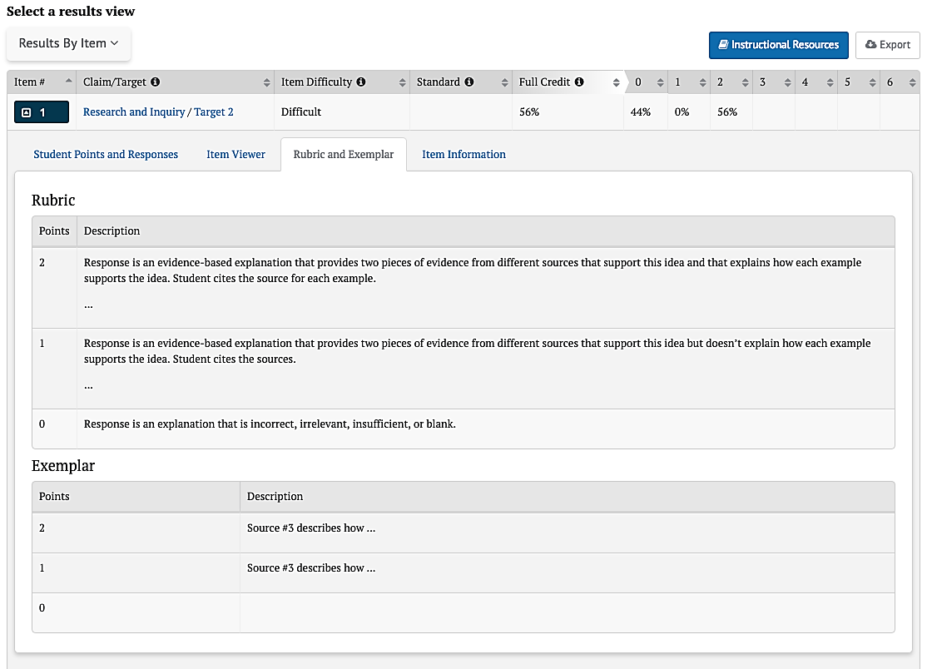

Figure 67. Rubric

##### Item Information

The Item Information view displays a detailed description of the assessment item (figure 68).

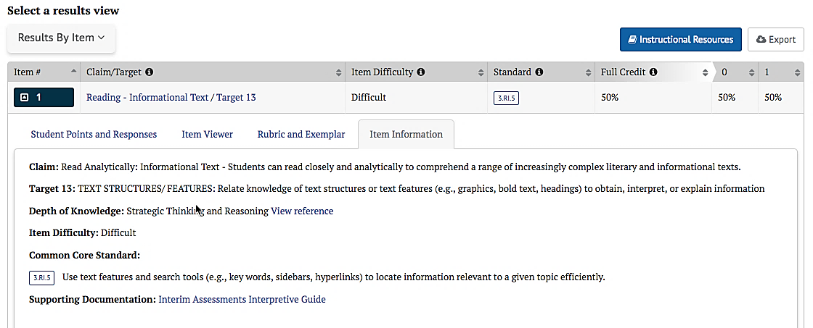

Figure 68. [Item Information] tab

Elements shown in the Item Information view may include:

* Claim—the major topic area of the test item content
* Target—the particular knowledge and skills measured by the test item
* Depth of Knowledge (DOK)—the level of cognitive demand this test item requires; includes a link to the DOK matrix
* Item Difficulty—one of three possible values: Easy, Moderate, Difficult
* Common Core State Standards (CCSS)—the content standard(s) that define what students should understand and be able to do
* Mathematical Practice Standard—for mathematics questions, the CCSS Standards for Mathematical Practice describe the varieties of expertise that mathematics educators should seek to develop in students
* Calculator—for mathematics questions, whether or not a calculator was available to students completing this item
* Supporting Documentation—a link to the *Interpretive Guide*

#### Key / Distractor Analysis

The *Key / Distractor Analysis* feature allows the user to evaluate whether there may have been common areas of misunderstanding among students who chose incorrect answers, called “distractors,” in selected-response items for interim assessments.

1. When the Key / Distractor Analysis option is active, the results panel shows an aggregate view similar to that of the Results By Item table, but with the percent distribution of student responses by answer option, as shown in figure 69.

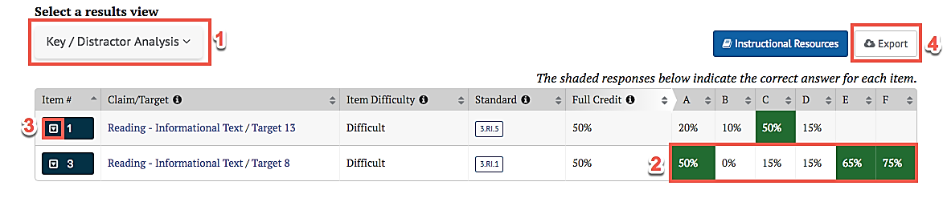

Figure 69. Key / Distractor Analysis results

1. The Key / Distractor Analysis table appears as described in the [Results By Item](#IAB Results By Item) section, with the following difference:

The columns indicating students’ score-point levels are replaced by columns that indicate the percentage or number of students who selected each answer choice. The correct answers are highlighted in green.

**Note:** For multi-select items, the details in Columns A through F may add to more than 100 percent because each student can select multiple answers.



Selecting an item’s down-arrow icon [] expands the row to reveal additional details; refer to the Results By Item Details section.

Users may sort each column to quickly identify items of interest. Additionally, an [Export] button is available to export the results of the report to a CSV file.

#### IAB Writing Trait Scores

Writing trait scores are displayed for ELA Performance Task IABs that include a written extended response (essay) item.

* Selecting the *Writing Traits Scores* from the *Results View* panel shows a Results By Item table with an aggregate view of how the students performed on the extended written response item. Only items with writing trait information are listed, as shown in figure 70.

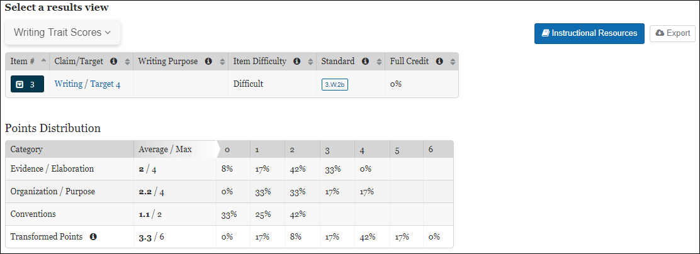

Figure 70. Writing Trait Scores results

The Results By Item table appears just as described in the [IAB Results By Item](#IAB Results By Item) section, with the following differences:

* A new column, Writing Purpose, displays the purpose of the writing tasks (argumentative, explanatory, informational, narrative, or opinion).

**Note:** The columns indicating the percentage or number of students who scored at each possible score-point level on the item are not displayed.



* Selecting an item’s drop-down arrow [] icon expands the row to allow viewing of the item and additional information about the item (refer to the IAB Results By Item Details section).
* Additionally, the Writing Trait Scores view shows a Points Distribution table.
* Each row lists the category of writing performance, or writing trait (Evidence / Elaboration, Organization / Purpose, and Conventions); the average and maximum points for that category; and the percentage or number of students who earned each number of points for that category.
* The final row is for the transformed points calculated from all categories (refer to the *Interpretive Guide* for an explanation of how transformed points are calculated for extended written response items).



**Note:** The Points Distribution table is not sortable.

* An [Export] button is available to export the results of the report—both the Results By Item table and the Points Distribution table combined—to a CSV file.

#### IAB Dashboard

The IAB Dashboard provides a summary of IAB assessments taken over the course of a school year for a group of students. The dashboard also provides an easy way to select these assessments to generate a detailed assessment report. Selecting the [View IAB Dashboard] button on the Search Group panel shown in figure 71 will display this dashboard, shown in figure 72.

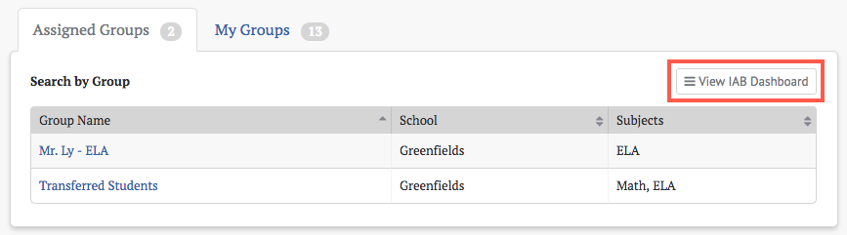

Figure 71. [View IAB Dashboard] button

**Note:** The [View IAB Dashboard] button appears on both the *Assigned Groups* and *My Groups* panels, but it brings up the same dashboard page regardless of where it is selected.



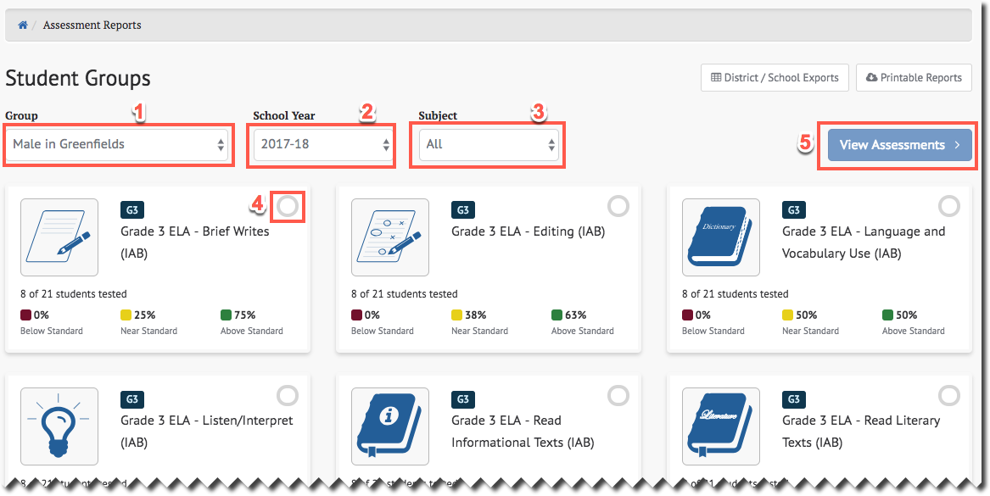

Figure 72. IAB Dashboard

The IAB Dashboard displays a quick-look summary of IAB results based on the selectors provided. It shows the total number of students from the selected group and how many participated in each IAB, as well as basic performance statistics for each assessment. One or more of these assessments can then be selected and used to generate more detailed reports.

1. Group selector—contains all the groups from the Assigned Groups and My Groups panels. It will default to a group belonging to the panel from which the [View IAB Dashboard] button was selected, but may be changed to any group from either panel.
2. School *Year* selector—the dashboard can only display IAB results from a single school year.
3. Subject selector—can be set to limit the displayed IABs to a single content area or set to All.
4. IAB selection indicator—When an IAB card is selected a checkmark appears, which indicates that this IAB is selected. Multiple IABs may be selected at the same time.
5. [View Assessments] button—selecting this button will generate assessment reports for all the selected IABs. It is disabled until at least one IAB is selected.

#### ICA Results

The ICA Results panel contains many of the same elements as the IAB Results panel and is shown in figure 73.

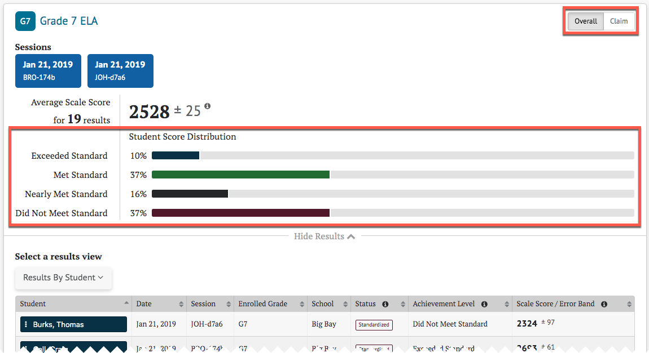

Figure 73. ICA results panel

The ICA results differ from the IAB results in the following ways:

1. The Student Score Distribution has four achievement levels rather than three reporting categories.
2. There are buttons to toggle between Overall and Claim scoring.
3. The [Instructional Resources] button is not displayed because Instructional Resources are only linked to Interim Assessment Block (IAB) results
4. When the Select a results view drop-down selection is [**Results By Student**], the ICA Results By Student table is displayed, which differs from the IAB Result By Student table; refer to the ICA Results By Student section.

#### ICA Results By Student

The Results By Student table for ICA results can be toggled to show Overall or Claim scores. Overall is the default selection.

##### ICA Results By Student Overall Scores

When the [Overall]button is selected, the Interim Comprehensive Assessments (ICA) Results By Student view includes the information elements for each student shown in figure 74.

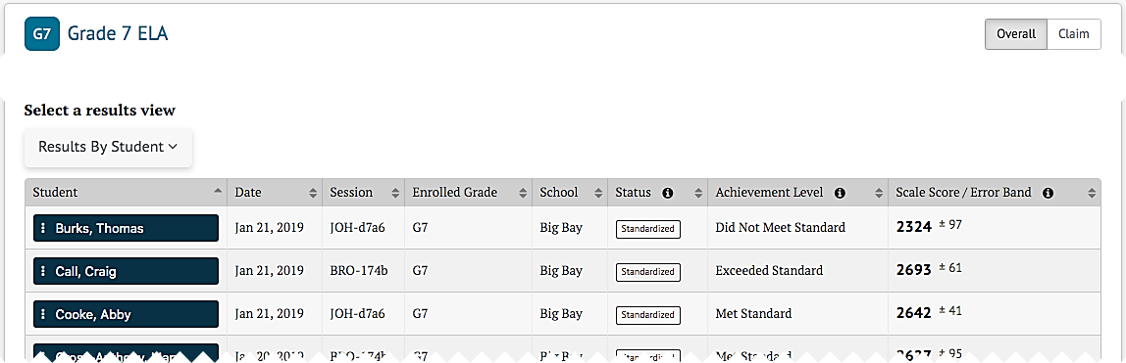

Figure 74. ICA Results By Student

* Student’s full name
* Date of assessment
* Assessment session
* Student’s enrolled grade at the time of the assessment
* School where the assessment occurred
* The assessment status, which includes whether it was standardized or nonstandardized, and whether it was partially complete
* Student’s achievement level on the assessment: one of “Did Not Meet Standard,” “Nearly Met Standard,” “Met Standard,” or “Exceeded Standard”
* Student’s scale score and score error band based on the SEM associated with that score
* A [**Context Menu**] three dots icon []that provides access to additional student details (Refer to the IAB Student Options section.)

##### ICA Results By Student Claim Scores

When the [Claim] button is selected, the ICA Results By Student view changes to show each student’s assessment results by Claim, as shown in figure 75. Return to the default view by selecting the[Overall] button.

The *Student Claim Score Distribution* displays the number/percent of students scoring in each reporting category (Below Standard, Near Standard, and Above Standard) for each claim.

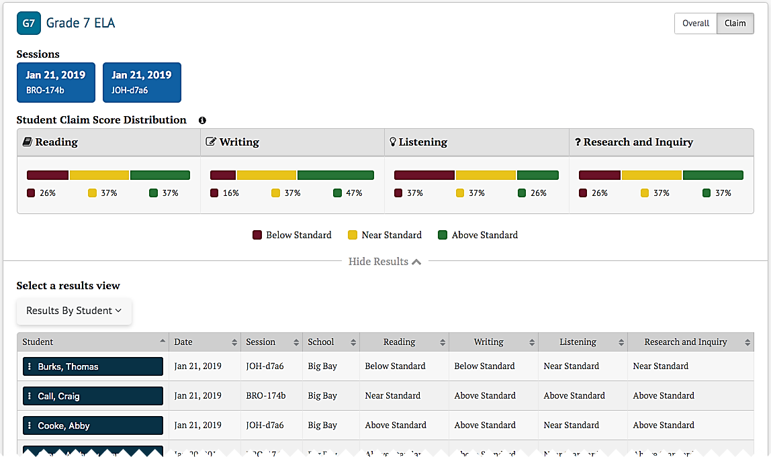

Figure 75. ICA Results By Claim Scores

Each student result in the Claim Scores view shows the following elements:

* Student’s full name
* Date of the assessment
* Test session
* School where the assessment was administered
* Student’s performance, noted as Above Standard, Near Standard, or Below Standard, for each of the assessment claims (The previous example shows the ELA claims: Reading, Writing, Listening, and Research and Inquiry.)
* A [**Context Menu**] three dots icon [] provides access to additional student details; refer to the IAB Student Options section

#### ICA Writing Traits Scores

The ICA writing traits scores are similar to the IAB writing traits scores, but do not include an [Instructional Resources]button. Writing trait scores are available for ELA ICAs. A sample is show figure 76:

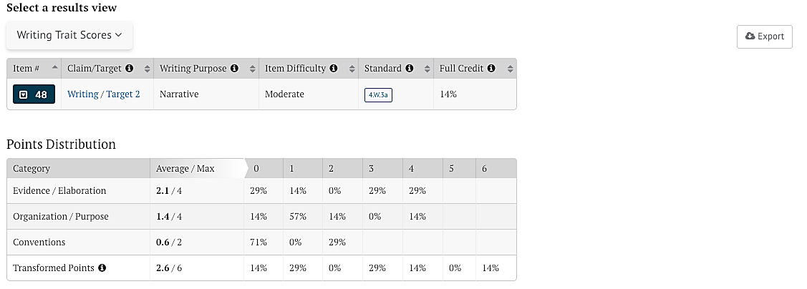

Figure 76. ICA Writing Traits Scores

### Summative Assessment Results

CERS will contain several Summative assessments including Smarter Balanced ELA and Math assessments, English Language Proficiency Assessments for California (ELPAC), and California Alternate Assessments (CAA) for ELA and Math.

In CERS, the main difference between interim assessments and summative assessments is that only interim assessments display item-level data.

#### Smarter Balanced Summative Assessment Results for ELA and Math

The Smarter Balanced Summative assessments have two performance scores: Overall and Claim. For Overall scores, the **[Overall]** toggle displays the *Student Score Distribution* with four achievement levels; refer to the ICA Results By Student Overall Scores section. For Claims, the **[Claim]** toggle displays four claims with three reporting categories; refer to the ICA Results By Student Claim Scores section.

A Smarter Balanced Math *Summative* results panel is shown in figure 77.

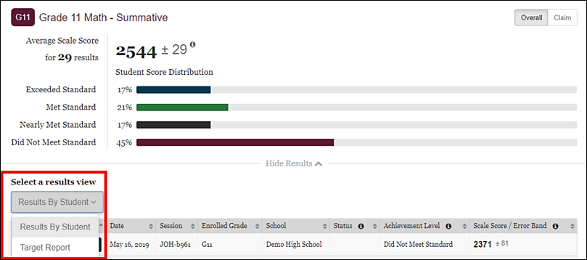

Figure 77. *Summative* results panel

The Smarter Balanced *Summative* results panel differ from the ICA Results in the following ways:

* 1. *Select a Results View* drop-down does not contain either Results By Item or Key / Distractor Analysis. These views are not available for summative assessments.
  2. *Select a Results View* drop-down will contain a *Target Report*. Refer to the Target Reports section for more details.
  3. There are no testing session cards displayed. The session name, if applicable, it will display in the *Results by Student* table.

##### Target Reports

Each Smarter Balanced Claim for ELA/literacy and mathematics includes a set of assessment targets that provide more detail about the range of content and Depth of Knowledge levels. For the summative assessment, target-level scores are calculated for each ELA/literacy claim. For mathematics, target-level scores are calculated for Claim 1 only. The reporting system displays aggregate target-level reports for each summative assessment. Target scores are reported as Performance Relative to the Entire Test and Performance Relative to Level 3 (Met Standard).

##### Performance Relative to the Entire Test

Performance Relative to the Entire Test is reported in one of three reporting categories: Better, Similar, or Worse. This report Indicates whether students' performance on a target was better than, the same, or worse than the students' performance on the entire test. A "Worse" indicator does not necessarily mean poor performance on a target, but rather that students' performance in this area was weaker than the overall performance.

###### Performance Relative to Level 3

Performance Relative to Level 3 (Met the standard) is reported in one of three reporting categories: Above, Near, or Below. This report Indicates whether students' performance on a target was above, near, or below the performance standard (Level 3: Met the standard). A "Below" indicator suggests that students have not yet mastered the content assessed in a target; however, the students' overall performance on the test may be near or above standard.

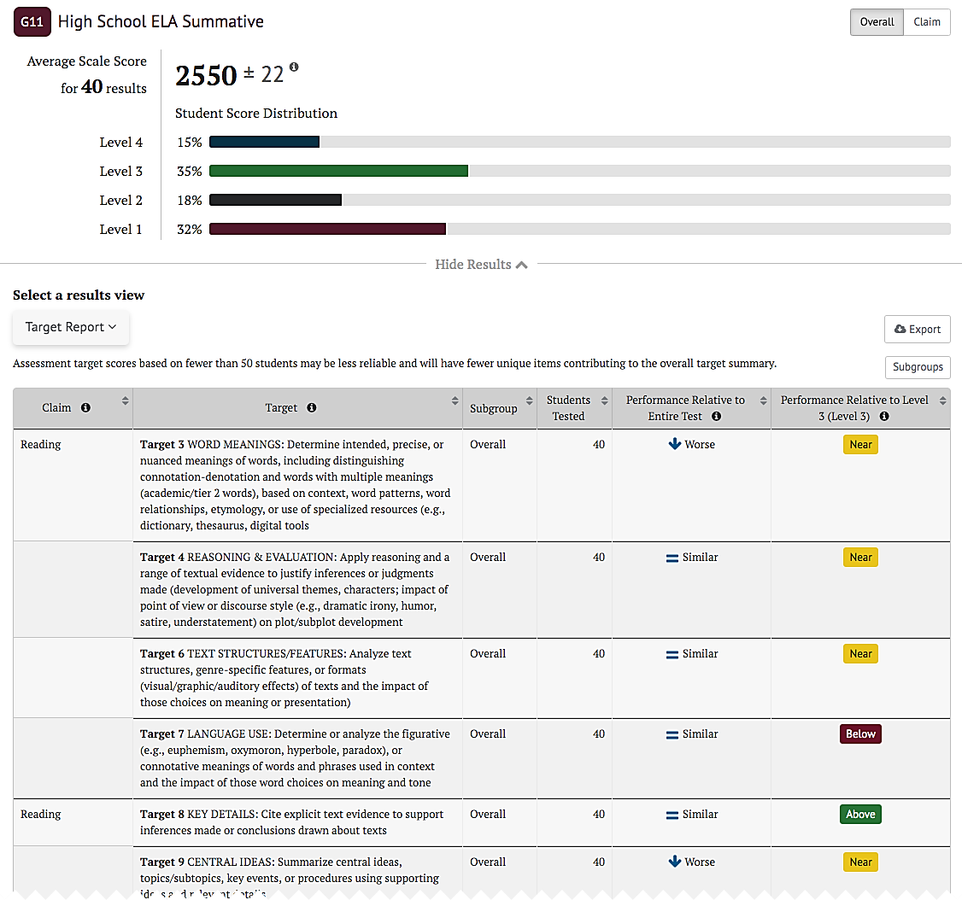

Figure 78. Performance Relative to Level 3

#### ELPAC Summative Assessment Results

Similar to Smarter Balanced summative assessments, the ELPAC Summative *Student Score Distribution* has four achievement levels. However, the ELPAC Summative has three performance scores: Overall, Composite, and Domain.

An ELPAC *Summative* results panel is shown in figure 79.

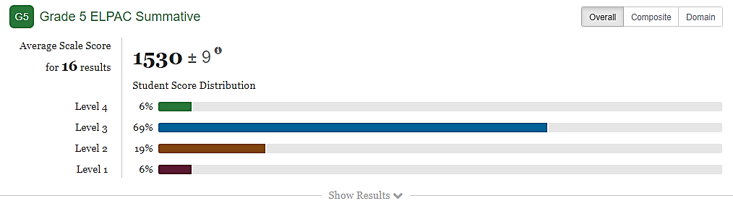

Figure 79. *Summative* results panel for ELPAC Summative

The ELPAC *Summative* results panel differ from the Summative Balanced Results in the following ways:

* 1. The toggle buttons for Performance Scores include [**Overall**], [**Composite**], and [**Domain**].
  2. The *Student Score Distribution* has four achievement levels with different nomenclature.

The *Composite* results display shows an aggregate of the domains into two categories called oral language and written language as shown in figure 80.

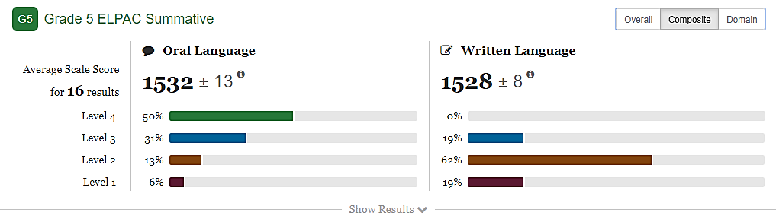

Figure 80. *Composite* results panel for ELPAC Summative

The *Domain* results panel displays the four Domains: Listening, Speaking, Reading, and Writing as shown in figure 81. The *Student Domain Score Distribution* displays three reporting categories: Beginning to Develop, Somewhat/Moderately, and Well Developed.

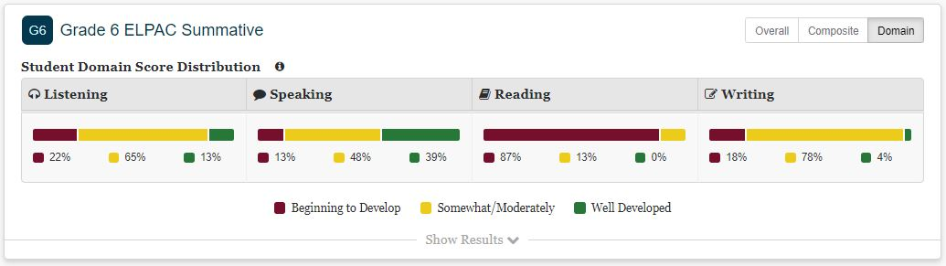

Figure 81. *Domain* results panel for ELPAC Summative

#### CAST Results

The CAST assessments have two sets of performance scores: Overall and Domain. For Overall scores, the **[Overall]** toggle displays the *Student Score Distribution* with four achievement levels (Standard Not Met, Standard Nearly Met, Standard Met, Standard Exceeded). For Domains, the **[Domain]** toggle displays three domains (Earth and Space Science, Life Sciences, Physical Sciences) with three reporting levels (below standard, near standard, above standard) for each domain.

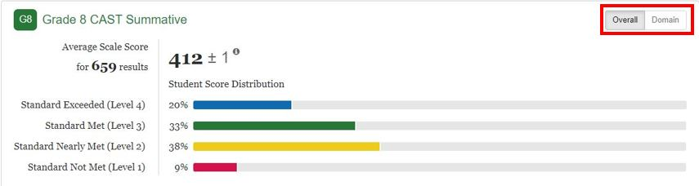

Figure 82. *Summative* results panel for CAST

The CAST *Summative* results panel differs from the Smarter Balanced Summative Results in the following way:

1. The toggle buttons for performance scores include **[Overall]** and **[Domain]**.

The *Domain* results panel displays the three Domains: Life Sciences, Physical Sciences, and Earth Sciences as shown in figure 83. The *Student Domain Score Distribution* displays three reporting categories: Below Standard, Near Standard, and Above Standard.

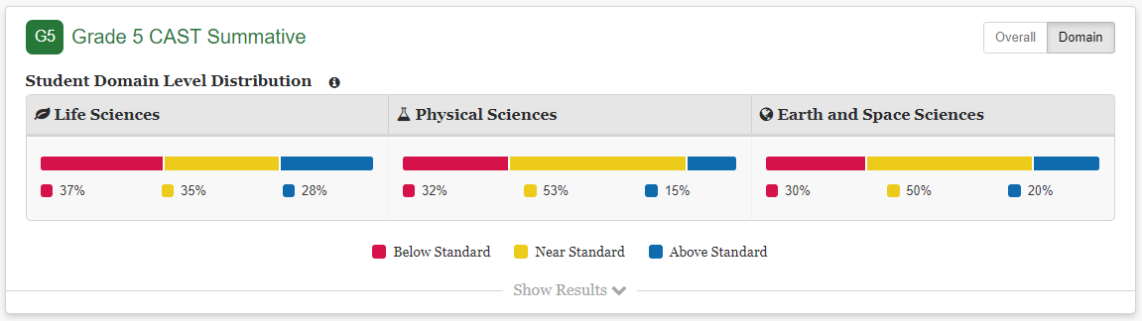

Figure 83. *Domain* results panel for CAST

#### CAA Summative Assessment Results for ELA and Math

The CAA Summative assessments have only one performance score called Overall. For both ELA and math, the *Student Score Distribution* displays three achievement levels.

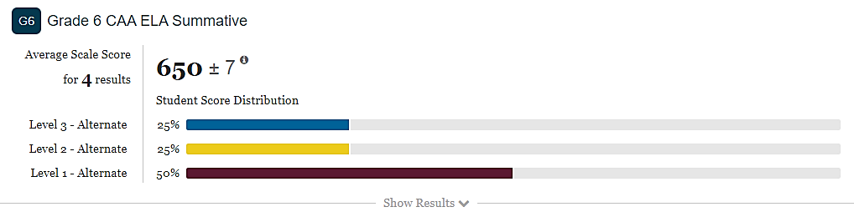

Figure 84. *Summative* results panel for CAA Summative

The CAA *Summative* results panel differ from the Smarter Balanced Summative Results in the following ways:

* 1. There is no toggle button.
  2. The *Student Score Distribution* has three achievement levels with different nomenclature.

#### CSA Results

CSA results have only one performance score called Overall. The *Student Score Distribution* displays three ranges.

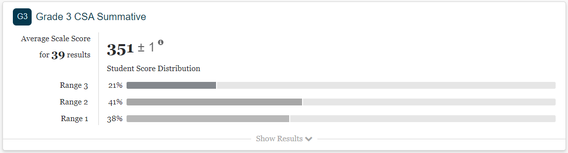

Figure 85. *Summative* results panel for CSA

The CSA *Summative* results panel differ from the Smarter Balanced Summative Results in the following ways:

* 1. There is no toggle button.
  2. The *Student Score Distribution* has three ranges with different nomenclature.

### Custom Aggregate Reports

Administrators with the CUSTOM_AGGREGATE_REPORTER role can create custom aggregate reports to access a customized summary of student performance in the user’s state, district, or school. The report can be broken down by student subgroups (e.g., race/ethnicity, migrant status) and may include summary information on performance at other levels (i.e., a school report can also include a summary of performance in that school’s district). Specialized reports allow tracking of performance broken down by claims and/or targets, and tracking performance for groups of students over the course of multiple years.

The Custom Aggregate Report Query page is accessed by the [Custom Aggregate Report] button on the home page.

Selecting the button opens the Custom Aggregate Report Query page. This page allows an administrator to select a report type, identify desired data and filters, and generate a report. The data and filters are selected from each of the following sections of the page:

* Report Type
* Schools and Districts
* Assessment Attributes
* Subgroup
* Advanced Filters
* Customized Subgroups

This page provides a preview of the report layout. Once reviewed, the administrator names the report and selects the [**Create Report**]button to generate a report.

#### Report Type

The Report Type section of the page () allows different report types to be selected. The Longitudinal Report and Target Report will only display if summative assessment results are available in the system.

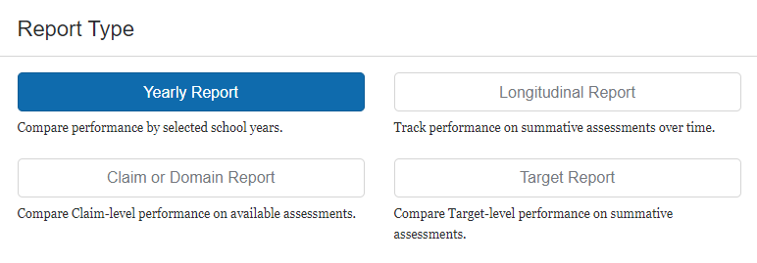

Figure 86. Report Type Section

1. Yearly Reports are the basic performance report. These reports summarize IAB, ICA, or summative assessment performance for student populations from one or more grade levels for one or more years of available data.
2. Longitudinal Reports track summative assessment performance for a single student population as that population progresses through different grades. In addition to presenting tabular data, these reports include a line graph showing how the performance of the population changed from grade to grade. These reports are only available if the reporting system includes summative assessment results.
3. Claim and Domain Reports are yearly reports that break down performance data by claim or domain for the ICA and summative assessments.
4. Target Reports are yearly reports that break down performance by claim and target for the Smarter Balanced summative assessments. Target reports are available for all ELA claims and the mathematics Concepts and Procedures claim only.

#### Schools and Districts

The Schools and Districts section of the page allows the user to specify which districts and schools are to be included in the report, as shown in figure 87.

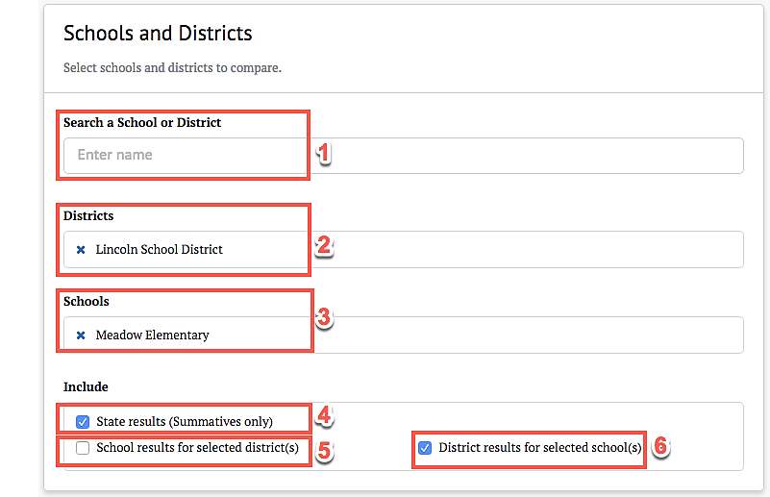

Figure 87. Schools and Districts section

The Schools and Districts section provides the following functionality:

1. Search a School or District—This allows the selection of a school or district to be included in the report. Users with district-level permission may select multiple schools or the entire district. Users with state-level permission may select multiple schools or districts.
2. Districts—This displays the selected districts to be included in the report
3. Schools—This displays the selected schools to be included in the report.
4. [**State results (Summative assessments only)**]—If selected, the report will include state summative assessment results.
5. [**School results for selected districts**]—If selected, the report will include the results for each school within each selected district
6. [**District results for selected schools**]—If selected, the report will include a results summary for each selected school’s district

#### Assessment Attributes

The Assessment Attributes section of the page allows for the specification of various attributes to be included in the report, as shown in figure 88.

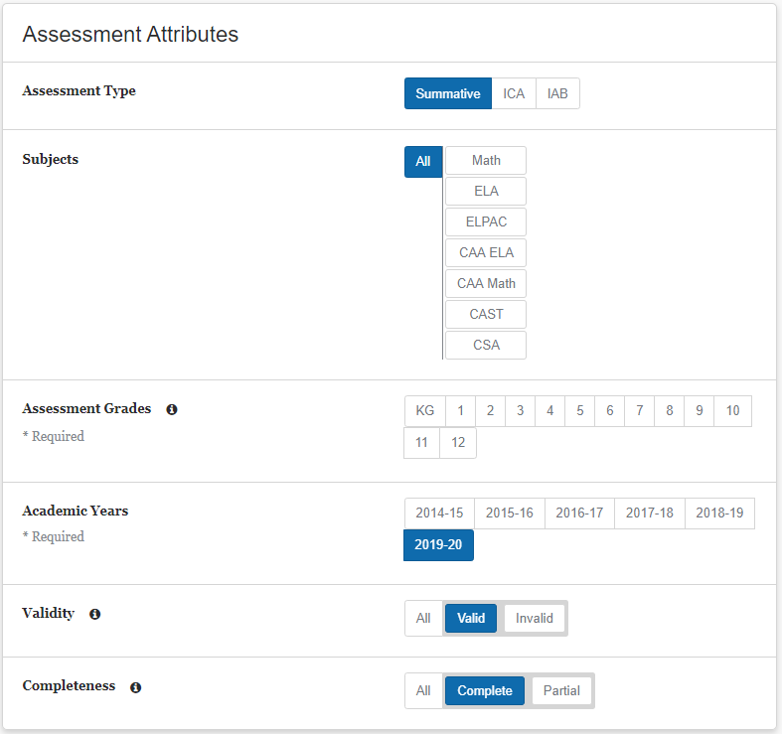

Figure 88. Assessment Attributes sections

The Assessment Attributes section provides the following attribute selections:

* Assessment Type—The choices are either [**ICA**], [**IAB**], or [**Summative**] (if available).
* Subjects—The choices are [**Math**], [**ELA**], and any other subjects configured in the user’s environment. The [**All**] option will cause the report to include results for all displayed subjects.

**Note:** *Subjects* can be configured to disallow Target Reports. If Target Report is the selected type, content areas that do not report target-level information will not be displayed as choices, and the report results will not include these content areas even if the [**All**] option is selected.



* Assessment Grades*—*One or more grades must be selected. A report will not be generated unless at least one grade is selected. For Target Reports, only a single grade may be selected.

**Note:** Longitudinal Reports track summative assessment performance for one student population as it progresses through different grade levels, so at least two grades must be selected for this report type.



* Academic Years—One or more academic years must be selected. A report will not be generated unless at least one academic year is selected. For Target Reports, only a single year may be selected.

**Note:** for Longitudinal Reports, only a single year can be selected, and it represents the year for the highest assessment grade selected. For example, if the grades selected are three and four and the year is 2019–20, the results will include the population’s grade three results for 2018–19 and grade four results for 2019–20.



* Manner of Administration/Validity—
* If *Assessment Type* is ICA or IAB, this attribute will be *Manner of Administration*, and it defaults to [**Standardized**]. It can be changed to [**Nonstandardized**] to view results for nonstandardized assessments only, or to [**All**], which will generate a report with both types of administration.
* If *Assessment Type* is Summative, this attribute will be *Validity*. Choices are [**Valid**] or [**Invalid**]. The [**All**] option will generate a report with both valid and invalid results.
* Completeness—The default is [**Complete**], but it can be changed to [**Partial**] for partial assessments, or to [**All**], which will generate a report that includes results from assessments that are either complete or partial.

For Claim Reports only, an additional [Claims or Domains]button will appear in the *Subjects* panel. Selecting it will open a subpanel that allows specific claims or domains to be selected (figure 89). Only claims or domains from the included content areas can be selected, and only the selected claims or domains will appear in the generated claim report. For example, if the selections were as follows, the generated report would include all subjects and their related claims or domains.

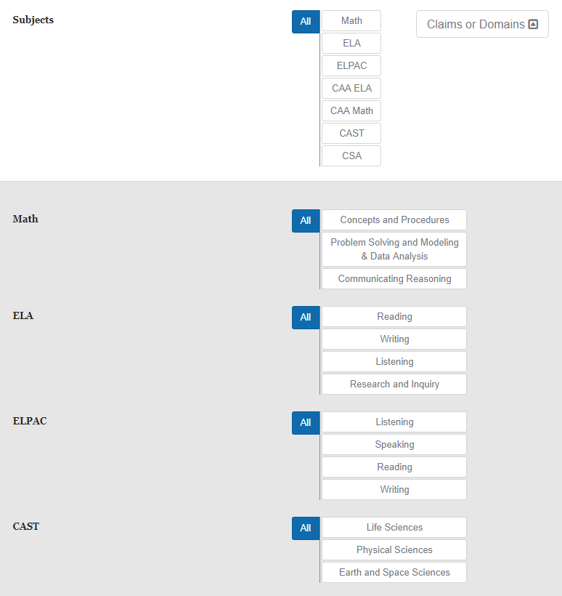

Figure 89. Claims Report subpanel

#### Subgroups and Filters

The *Subgroups and Advanced Filters/Customized Subgroup* panel provides two different strategies for configuring how student performance data are broken down within the report and how groups are filtered for inclusion in the report. These strategies are mutually exclusive, so at most, one of these panels should be configured. The generated report will use the setting from whichever tab is currently selected.

##### Subgroups

Reports include aggregate values for each institution. The Subgroups section of the page allows a user to select student subgroups that will be compared within the report, as shown in figure 90. The available subgroups that can be specified are [**Race / Ethnicity**], [**English Language Acquisition Status**], [**Primary Language**], and [**Migrant Status**].

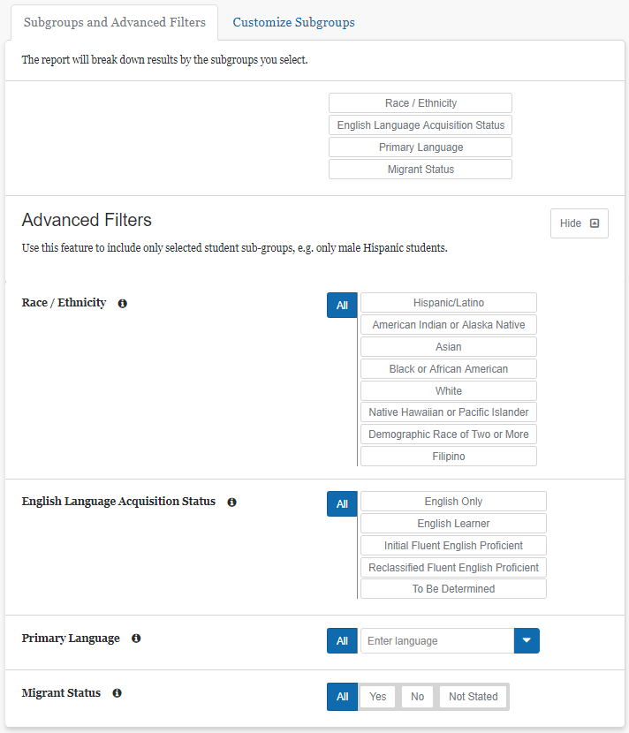

Figure 90. *Subgroups* section

##### Advanced Filters

The Advanced Filters section of the page can be displayed by selecting the [**Show**] button below the *Subgroup* controls, as shown in figure 91. It is useful when a user wants to focus on one or more student subgroups in a report and exclude all other students. The available filters are [**Race/Ethnicity**], [**English Language Acquisition Status**], [**Primary Language**], and [**Migrant Status**].



**Note:** The Advanced Filters selection will not appear in the generated reports or exports.

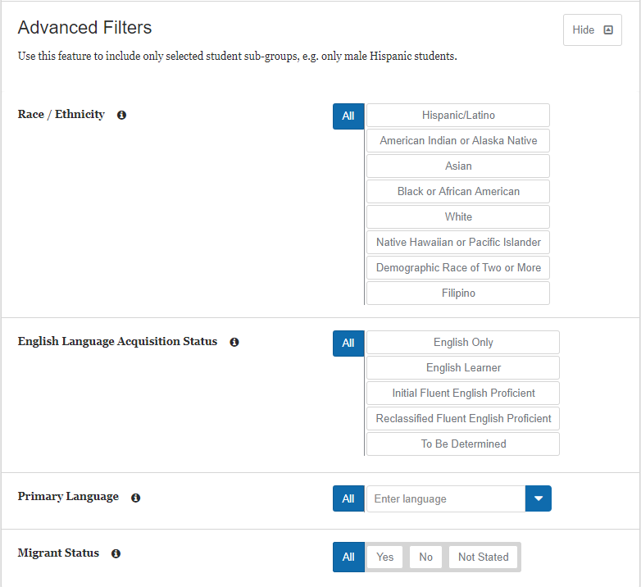

Figure 91. *Advanced Filters* section

##### Customize Subgroups

Customized subgroups provide complete control of which student groups are included in the generated report and how the report data are broken down. It can be used in cases where the *Subgroups* and *Advanced* *Filters* do not provide enough flexibility. The controls are similar to the *Advanced Filters*, but allow multiple groups to be defined, as shown in figure 92. The process is as follows:

1. Configure a subgroup using the filters as if creating an advanced filter.
2. Select the [+Create Subgroup] button to add this group to the report.
3. Repeat steps 1 and 2 to create additional subgroups.

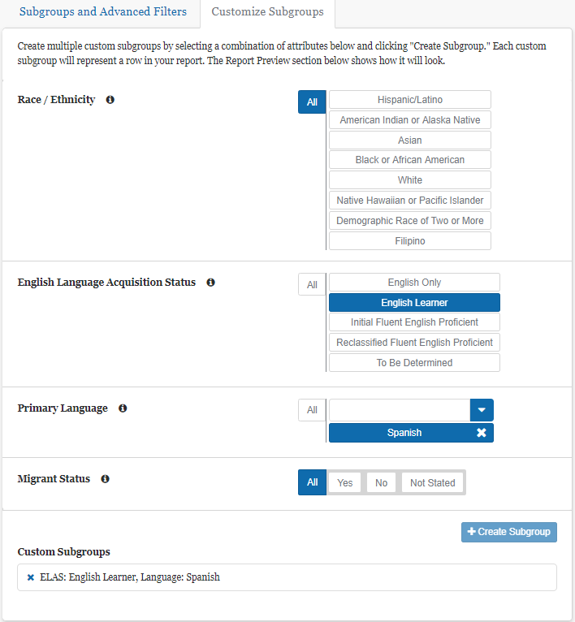

Figure 92. *Customize Subgroups* section

The report will include rows showing results for each of the defined subgroups, as well as overall totals for all test takers. Keep in mind that the subgroups do not need to be mutually exclusive. For example, one subgroup could be defined as all students whose primary language is English and a second subgroup could be all English learners whose primary language is Vietnamese or Filipino. Depending on how subgroups are defined, some students could fall into multiple subgroups, while others fall into no subgroups at all. Therefore, the subgroup totals will not always sum to the overall totals.

**Note:** The Customize Subgroup configuration is not available for Target Reports.



#### Report Review

**Tip:** Each report is saved with the report name and can be accessed on the My Reports page, which is accessible from the home page. Save each report with a descriptive name that will allow it to be easily retrieved later. If no report name is entered, it will be saved as a “Custom Aggregate Report.”



**Note:** All required fields must be populated before the report may be generated.



The Report Review section of the page (figure 93) allows an administrator to review the selected criteria included in the report.

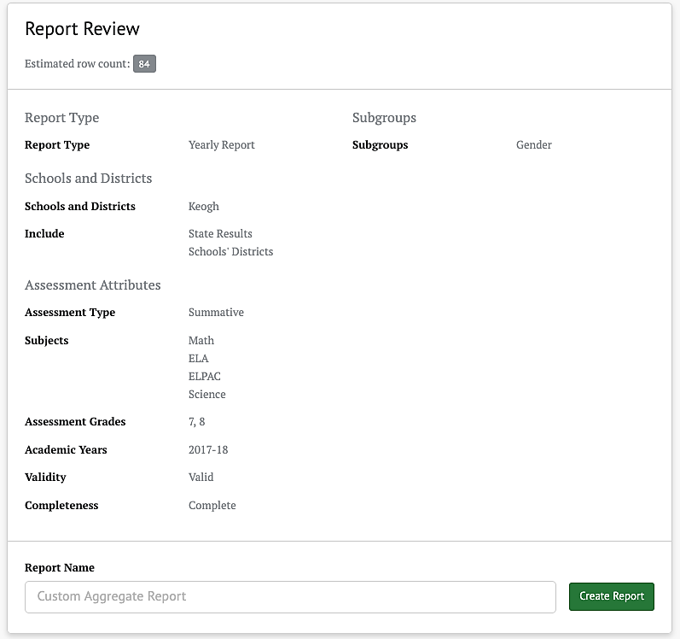

Figure 93. Report Review section

* Estimated row count: Provides an estimate on how many rows the report will have, in order to provide some feedback on how large the report will be before generating it
* Report Name: The report may be given a name here
* [Create Report]: The report is generated by selecting this button

#### Report Preview

The Report Preview section of the page allows an administrator to access a preview of the selected attributes with mock data, as shown next, before generating the actual report, as shown in figure 94.

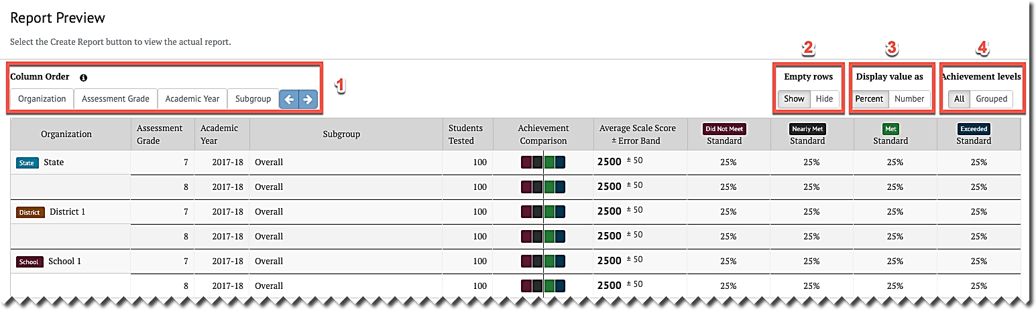

Figure 94. Report Preview section

The Report Preview section provides additional viewing options:

1. Column Order**—**Allows the option to change the result column order to easily compare results broken down in different ways
2. Empty Rows—When the [Show] button is selected, rows with no data will be included in the preview. When the [Hide] button is selected, these empty rows will be excluded from the report. In this case, if a report section has only empty rows, it also will be excluded.
3. Display Value As**—**Choices are [Percent] or [Number].
4. Achievement Levels—Choices are either [All] or [Grouped]. If [All] is chosen, all achievement levels are displayed in the report. If [Grouped] is chosen, then Achievement Levels below the standard cutoff are combined into one result, labeled *Below Standard* and Achievement Levelsabove the standard cutoff are combined into one result, labeled At or Above Standard (refer to figure 95).

**Tip**: For large reports with many rows, hiding empty rows in the preview, *before the report is created*, may decrease report generation time and make viewing the report faster.



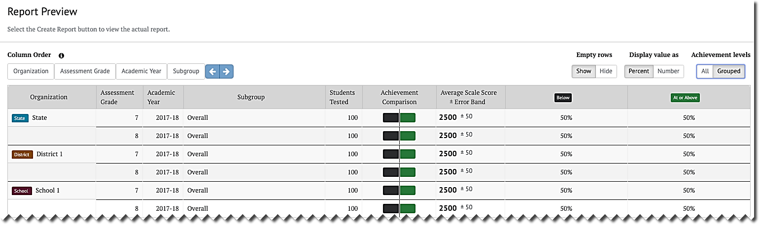

Figure 95. Achievement levels display

#### Creating the Custom Aggregate Report

The report is generated by selecting the [Create Report] button on the left side of the page, as shown in figure 96. The button is also available on the Report Review section of the page.

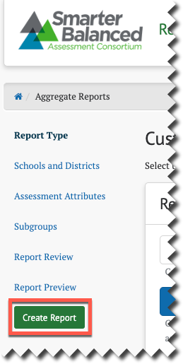

Figure 96. [Create Report] button

When this button is selected, a Custom Aggregate Report is created, and when completed, the report will be displayed in the Custom Aggregate Report page, shown in figure 97.



**Note:** This report may take several minutes to generate.

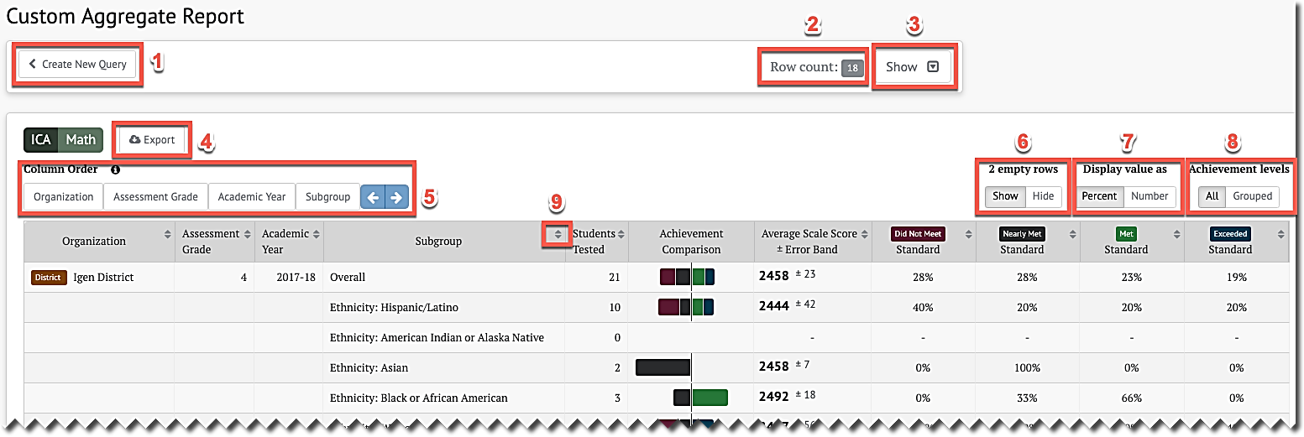

Figure 97. *Custom Aggregate Report* page

The Custom Aggregate Report page has the following features and options:

1. The [Create New Query] button will go back to the Custom Aggregate Report Query page with the same settings that were used to generate this report. From here, the settings can be modified and used to generate a new report.

**Tip:** Use the [**Create New Query**] button to quickly adjust an existing report query



1. Row count indicates the total number of rows displayed in the report. It is not possible to generate a report that contains zero rows. Instead, an error message will be displayed.
2. The [**Show/Hide**] toggle control, shown in figure 98, displays whether a panel listing the settings in the query is displayed. When the control is in the [**Show**] state, selecting it will display the query settings as shown and set the control to the [**Hide**] state.

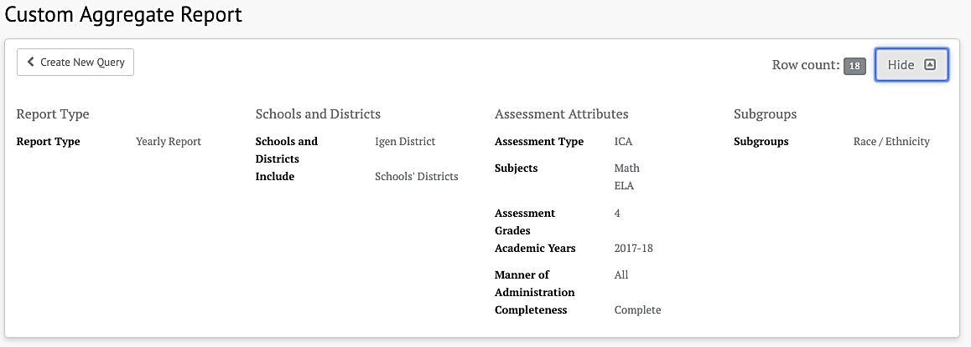

Figure 98. [Show/Hide] toggle on Custom Aggregate Report

1. The [Export] button will generate a CSV file with the contents of the report. The columns will be the same as displayed on the page, with one additional column: The Organization’s Natural Id (Column B), also known as the CDS code.
2. Column Order allows the option to change the result column order to easily compare results broken down in different ways.
3. Empty rows work as described in the Report Preview section.
4. Display value as works as described in the Report Preview section.
5. Achievement levels works as described in the Report Preview section.
6. The report results may be sorted either by ascending or descending value by selecting either the up or down button respectively for each column, as shown in figure 99.

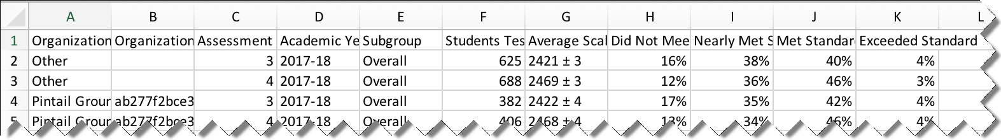

Figure 99. Custom Aggregate Report in ascending order

**Note:** It is possible for sections of aggregate reports to have all 0 totals. This indicates there are no results for these sections with the currently configured options and filters.



**Note:** Administrators can access every previously generated report by using the My Reports feature on the top navigation panel.



### District / School Exports

An administrator with either an LEA or a school PII role can export a CSV file containing all the district or school assessment results. There are no filtering or customization features for this report; however, the exported file may be filtered and sorted in a spreadsheet or database program. The export is specified in the District / School Exportspage, which is accessed by selecting the [District / School Exports] button on the home page.

The District / School Exports page elements are shown in figure 100.

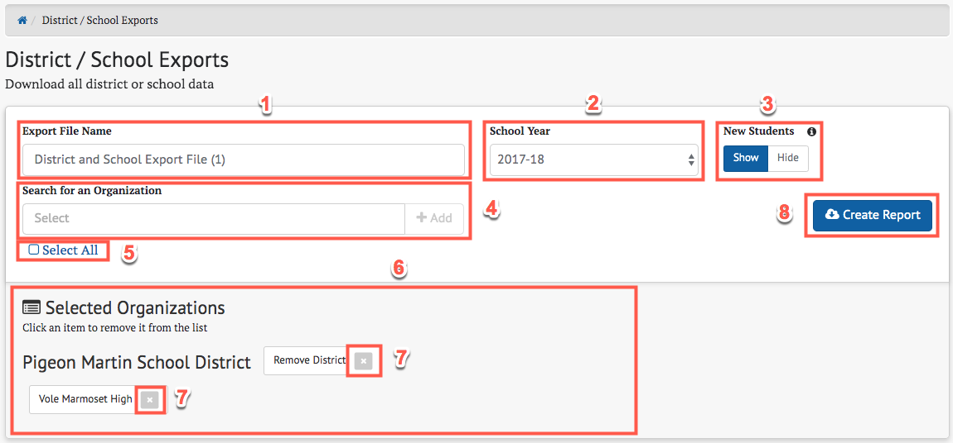

Figure 100. District / School Exports page elements

1. Export File Name: The user must enter a name for this report
2. School Year: The school year for the report
3. New Students: The [**Show/Hide**] toggle control allows the user to specify if assessments from other schools are to be included in the report
4. Search for an Organization: Allows the user to search for school(s) or districts, depending on the user’s permissions, to be included in the report
5. Select All: If checked, all allowed schools and districts will be included in the report
6. Selected Organizations: Displays all selected schools or districts that will be included in the report
7. A school or district may be excluded from the report by selecting the  icon of the school or district to be excluded.
8. Selecting the [Create Report]button will generate the report. The report can be viewed by going to the My Reports page.

If the [**Select All**] checkbox is selected, then all schools and districts allowed to be seen by the user will appear in the Selected Organizations panel, shown in figure 101.

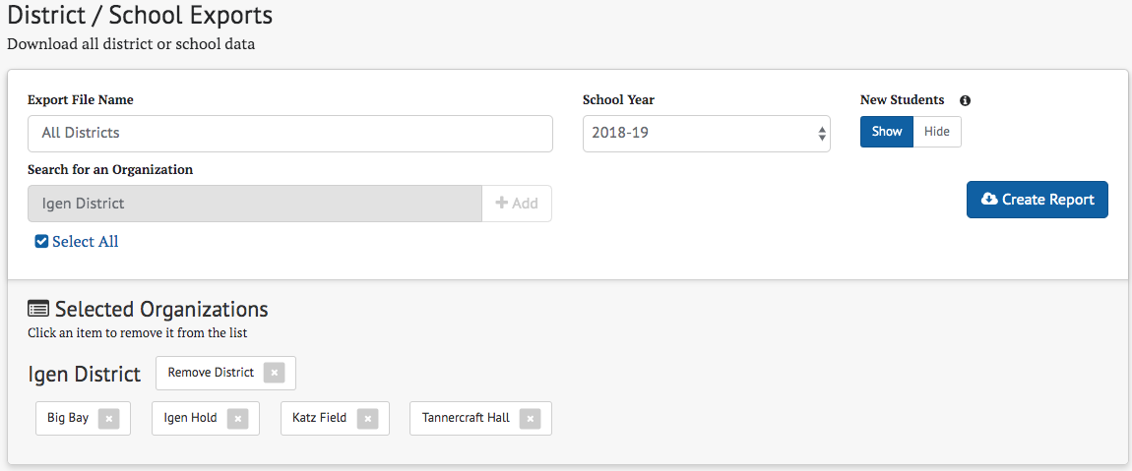

Figure 101. Selected Organizations panel

If the user has permission for only one school, the Search for an Organization search box is not visible. Furthermore, the Selected Organizations result panel is preloaded with that school and the school cannot be removed.

The School Year drop-down list allows for a school year to be selected for the report. A New Students toggle control allows the user to specify whether assessments administered to students at a previous school or LEA are to be included in the report. The report is generated by selecting the [Create Report] button. The report is a CSV file that contains a comprehensive report of all students in the selected schools for the selected school year.

### My Reports

All reports generated by the user appear in the My Reports page, which can be displayed by selecting the [My Reports]button on the home page as shown in figure 102 and 103.

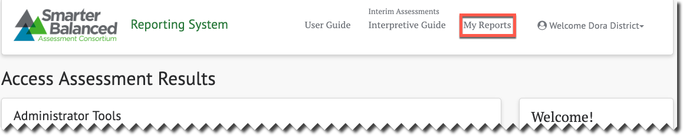

Figure 102. [My Reports] button on home page

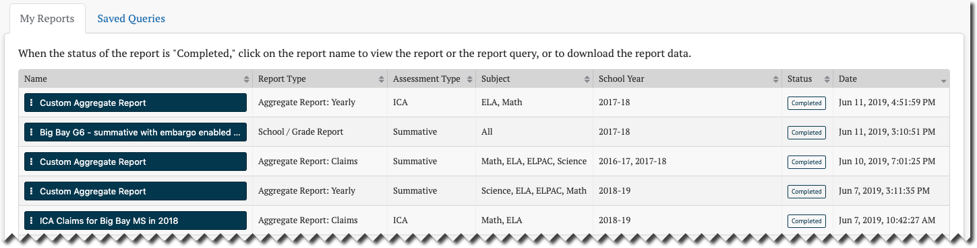

Figure 103. My Reports page

Selecting the [**Context Menu**] three dot icon[] on a report name opens a context menu for that report (figure 104). If the report type is “Aggregate Report,” then the context menu has the following options:

* [**View Report**]—displays the report in the Custom Aggregate Report page; refer to the Creating the Custom Aggregate Report section
* [**Download Report Data**]—downloads the report to a CSV file on the user's computer
* [**View Report Query**]—displays the query used to generate the report in the Custom Aggregate Query page section; refer to the Creating the Custom Aggregate Report section
* [**Save Report Query**]—saves the query so it can be used to create another report even after this report is deleted (Saved queries will appear in the [**Saved Queries**] tab described in the next section.)
* [**Delete Report**]—deletes this report from the My Reports list

**Warning:** Deleting a report is a permanent action and cannot be undone. It will also delete the report query unless this query has been previously saved to the [**Saved Queries**] tab.



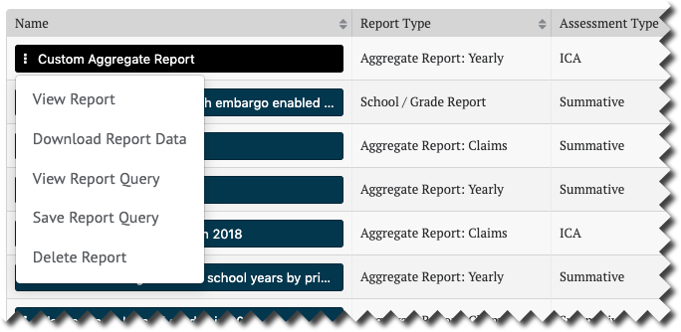

Figure 104. Report options in IAB Dashboard

If the report type of “Aggregate Report” has an assessment type of “Summative” and the results have not yet been released (i.e., the results are under embargo), then the [**Download Report Data**] option will be disabled (grayed out), as shown in figure 105.

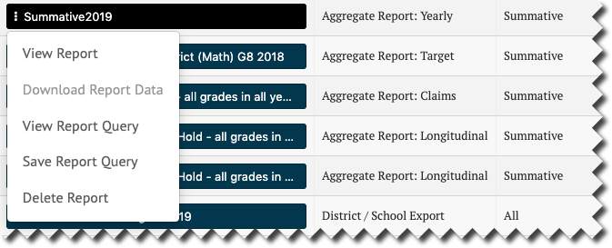

Figure 105. Download Report Data option disabled

If the report type is any other type other than “Aggregate Report,” the same context menu options will be available, except for View Report, as shown in figure 106.

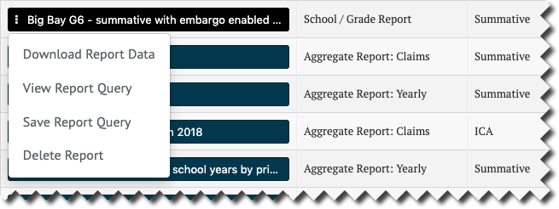

Figure 106. Menu for reports other than Aggregate Reports

### Saved Queries

Saved queries allow reports to be recreated, with query modifications, at any time, even after the original report the query was used for has been deleted. All queries saved by the user appear on the [**Saved Queries**] tab, which is next to the [**My Reports**] tab discussed in the previous section. This tab is accessed by selecting the [My Reports] button on the home page and then selecting the [**Saved Queries**] tab (figure 107).

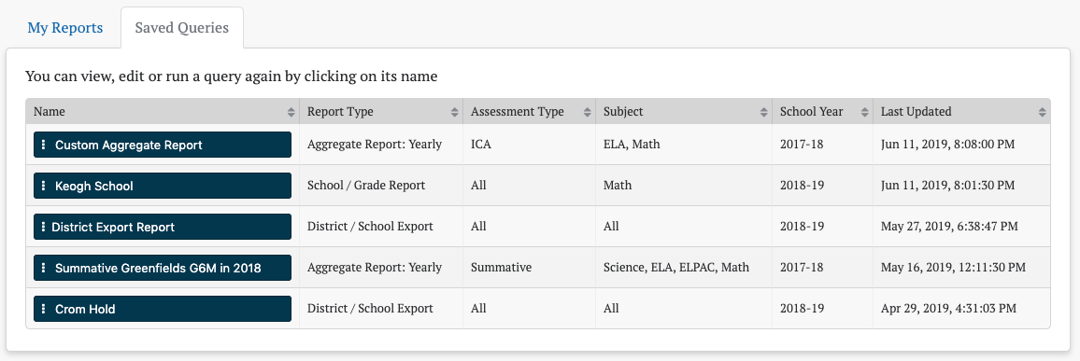

Figure 107. [Saved Queries] tab

#### Saving a Query

To create a saved query, select [**Save Query**] from the context menu of an existing report in the [**My Reports**] tab (figure 108), as discussed in the previous section.

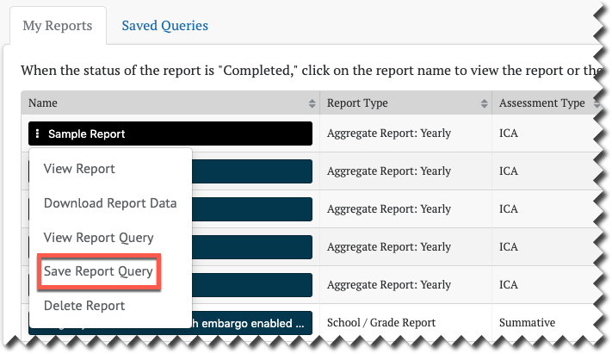

Figure 108. [Save Report Query] option

The query is added to the [**Saved Queries**] tab with the same name as the report, as shown in figure 109.

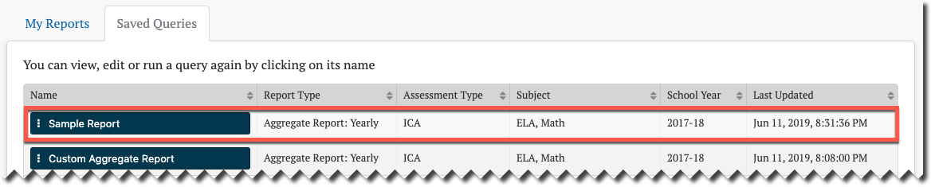

Figure 109. Query added to [Saved Query] tab

#### Editing a Saved Query

Selecting the [**Context Menu**] three dot icon [] on a saved query name opens a context menu for editing the query (figure 110).

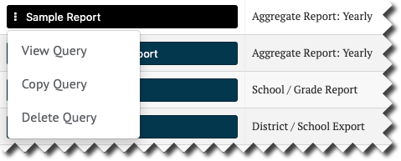

Figure 110. Editing Query context menu

The context menu has the following options:

* [**View Query**]—displays the query in the appropriate report form. This view will be similar to the original report creation interface for that report type, but will also include a [Save Query] button for saving the edited query.
* [**Copy Query**]—creates a duplicate of the query with a name that is a variation on the original query’s name. For example, if the query is named “Sample Report,” the copied query will be named “Sample Report (1).” The name can be changed by viewing the new query and saving it with a different name.
* [**Delete Query**]—deletes the query. This will not delete the original report from which the query was saved.

**Warning:** Deleting a query is a permanent action and cannot be undone. However, if the report from which the query was originally saved still exists in the My Reports tab, the query can be saved from the original again.



As an example, if [**View Query**] is selected from the context menu of the “Sample Report” query, the *Custom Aggregate Report* edit page will appear, prepopulated with the values from the saved query. This is because the “Sample Report” query is for an aggregate report. Viewing other queries would navigate to the edit pages appropriate for the query type. Any part of the query can be modified from this page. Refer to Custom Aggregate Reports for the use of these edit controls for aggregate reports, or the appropriate reporting section for reports of other types.

The one difference in these edit controls is the addition of a [Save Query]button to the Report Review panel (figure 111). This button will be disabled (grayed out) until at least one parameter of the query is changed or it is given a new name.

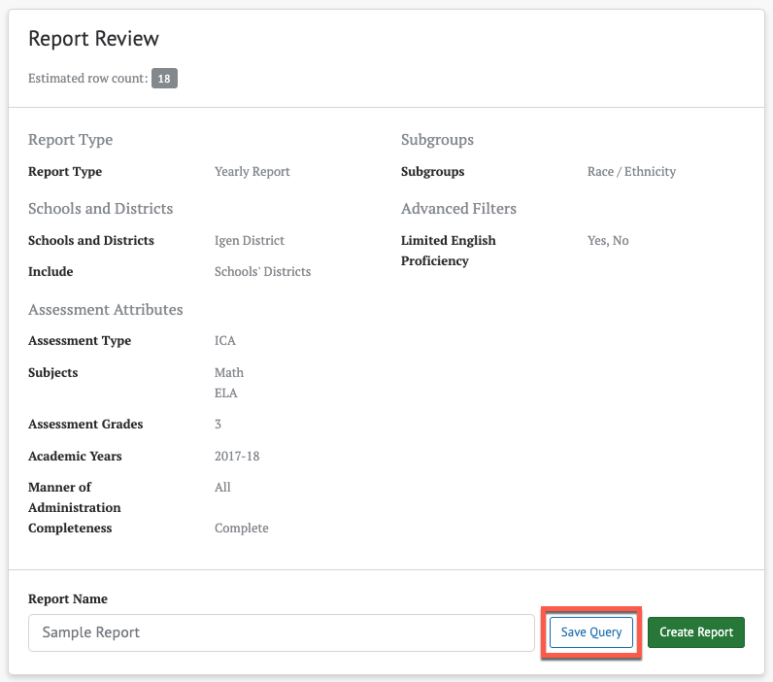

Figure 111. [Save Query] button

Selecting the [Save Query] button will save the edited query in place of the existing one. A dialog indicating a successful save will briefly appear in the upper right of the screen.

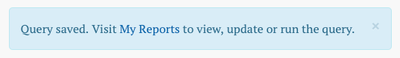

Saving the query does not navigate away from the edit page, which allows the user to select the [Create Report] button and immediately create a report based on the newly saved query.

**Tip:** Saving a query overwrites the existing saved query with new values, even if the query is given a new name during the save. If the intent is to create a second query with modified values, select [**Copy Query**] from the saved query’s context menu, and then [**View Query**] from the copied query’s context menu.



### Manage Student Groups

Administrators can create, view, and manage groups of students to allow users to easily view a collection of student assessment results. A student group could represent all the students in a teacher’s classroom or a particular period of instruction, for example. The TOMS roles and permissions system can be used in conjunction with student groups to allow teachers access to student test results.

The Manage Student Groups page is accessed by selecting the[Student Groups] button on the Home page.

The *Manage Student Groups* page elements are shown in figure 112.

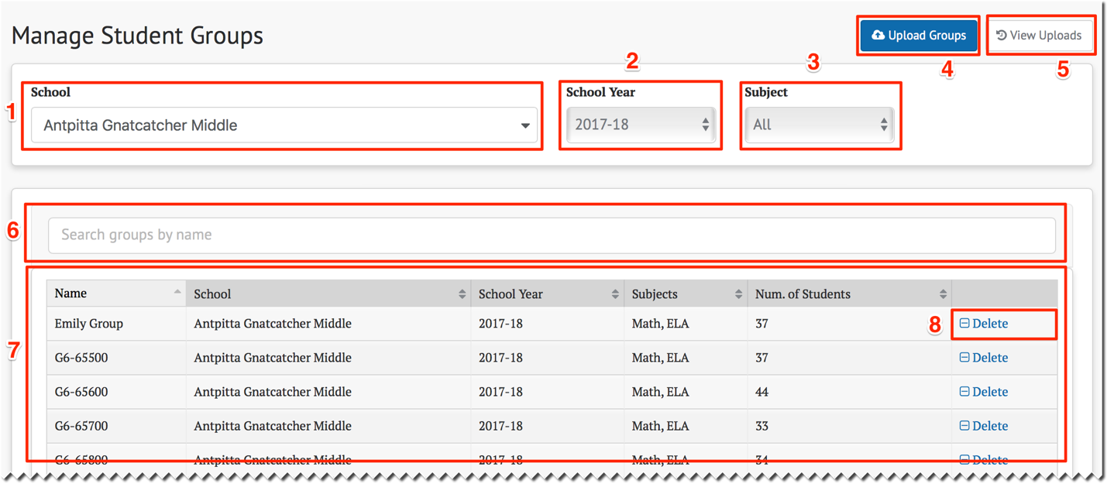

Figure 112. Manage Student Groups page

The Manage Student Groups page provides the following features:

1. School—Specify which school to search for groups
2. School Year—Specify which school year to search for groups
3. Subject—Specify which subject to search for groups
4. [Upload Groups] button—Create or update one or more groups
5. [View Uploads] button—View the history of group data uploads
6. Search groups by name—Search for groups by name to limit which groups are displayed
7. Student Groups List—Displays groups matching the filter conditions selected, including group and school name, school year, subject(s) and the number of students in the group
8. [**Delete**]—Button for the option to delete the group

Selecting a school, school year, or subject immediately updates the list of student groups displayed in the Student Groups List. If groups do not exist for the selected *School*, *Year*, and *Subject* filters, a message appears in the Student Groups List as shown in figure 113.

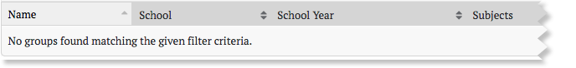

Figure 113. “No groups found” notice

#### Uploading Student Group Files

Selecting the [Upload Groups]button on the Manage Student Groups page opens the Upload Groups page shown next. Here, administrators can upload CSV files of student-group information by dragging the file(s) from a file system and dropping it into the dotted box or by browsing for files on a computer. The Upload Results list at the bottom will update the status of files after the files are uploaded. In the example in figure 114, no files have been uploaded yet.

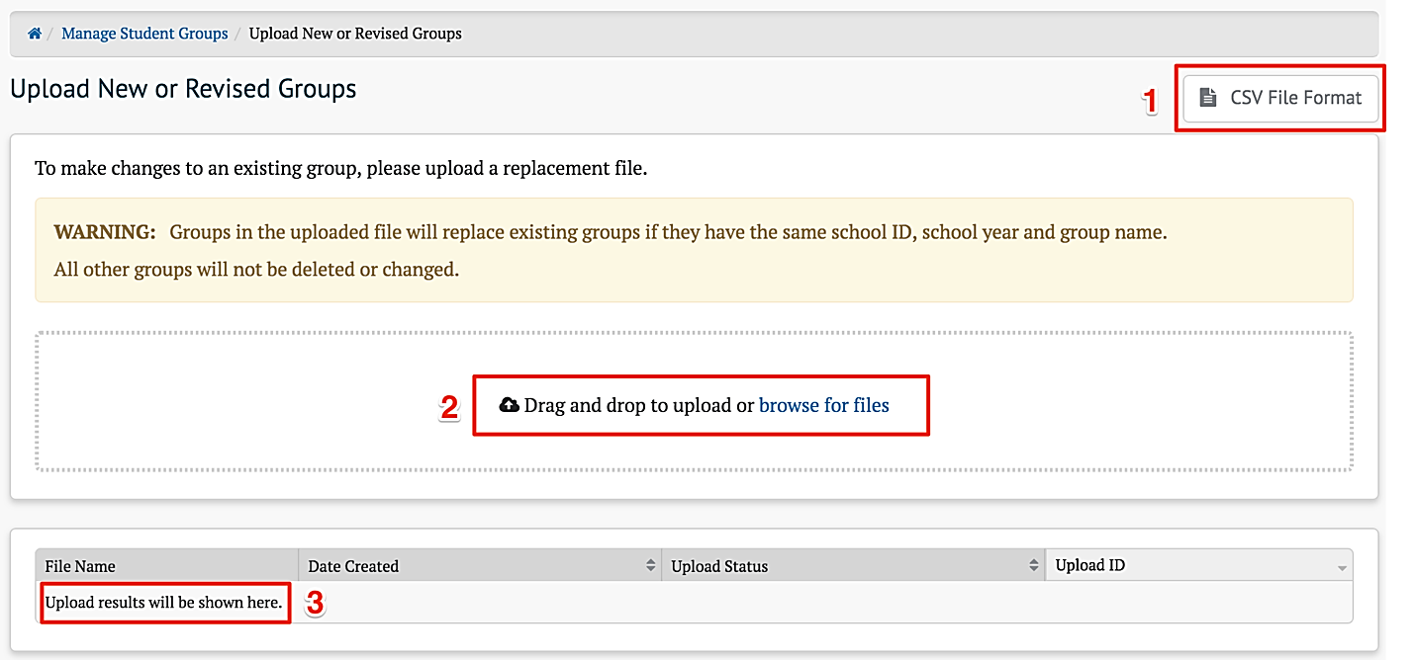

Figure 114. Upload Groups page without files

1. Selecting the [CSV File Format] button will display the CSV File Format page, which describes how to set up a CSV file to update; refer to Upload Template File and Validation Rules.
2. To upload a file, either drag it to this entry or select the “browse for files” to select one from the file system.
3. Results of uploads will be shown here.

If the uploaded file is properly formatted and passes all validation rules (refer to Upload Template File and Validation Rules), the system will display the file with an “Accepted” status. If the file is not properly formatted or fails validation, the system will reject the file and display a “Bad Data” status. Once the system has successfully processed the file, the system will update the file status to “Processed.” All of these results are shown in figure 115.

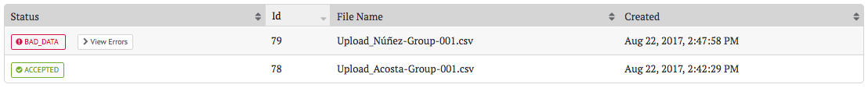

Figure 115. *Upload Groups* page with files

In the case of a failed upload, the system will display a [> View Errors] button. Selecting it will show the error(s) that caused the file to be rejected by the system. To be accepted, a student group file must be a properly formatted CSV file with column names and cell values matching the CSV file format template exactly.

#### Upload Template File and Validation Rules

Selecting the [CSV File Format] button will display the CSV File Format page, as shown in figure 116.

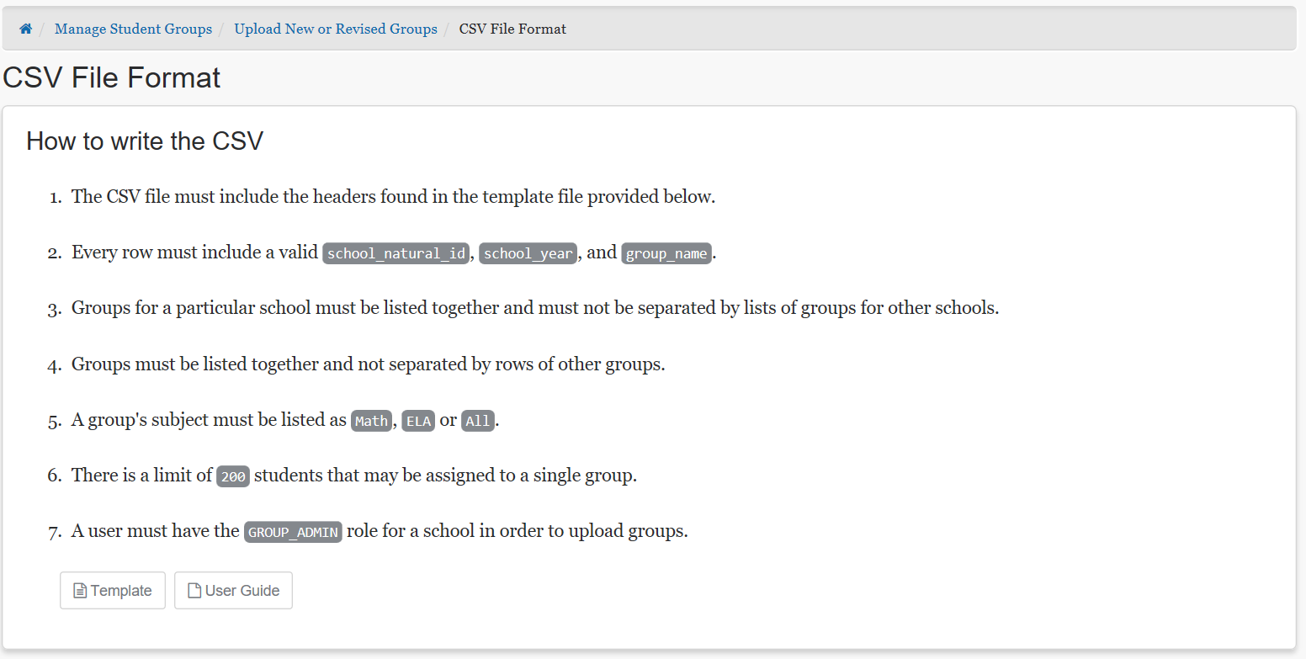

Figure 116. *CSV File Format* page

This page gives instructions on how to create a CSV file to be uploaded. Selecting the [Template]button will download a CSV file with required column titles, as shown in figure 117.

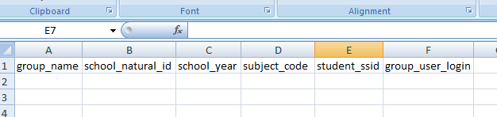

Figure 117. CSV file with column titles

The uploaded file must contain these column titles in the first row; column order must match exactly:

* group_name: name of the group (must be unique per school)
* school_natural_id: the school identifier (CDS code)
* school_year: four-digit school year (2018 represents the 2017–18 school year)
* subject_code: Subject Name (e.g., ELA, Math, ELPAC) or ALL
* student_ssid: statewide student identifier
* group_user_login: email address of one or more users who will have permission to access the group’s assessment results

In addition to these column title requirements, the following validation rules are applied to determine whether a file will be accepted:

* The input file must be in CSV format.
* Each row must contain valid values for school_natural_id, school_year, and group_name.
* Groups for a school must be listed together and must not be separated by lists of groups for other schools; a group is defined by the combination of school, school year, and group name.
* Each *user_group_login* cell may contain no more than one email address.
* No more than 200 students may be assigned to a single student group.

**Note:** If all rows for a group have a blank value for the subject code, the system automatically assigns a content area of “ALL.”



**Caution:** Once a student group has been created for the first time, any subsequent file uploads for that same group will replace ALL of the student records assigned to the group.



**Tip:** Although a group cannot explicitly be deleted with an upload, any group can be effectively deleted by creating a file that has the group with no students or users. Create the file with a single row containing just the school_natural_id, school_year, and group_name columns filled.



#### Working with Upload Files in Microsoft Excel

**Warning:** Excel may convert values to an alternative format. For example, the school_natural_id value is a long number (e.g., 12345671234567) that Excel may convert to scientific notation (e.g., 1.23457E+13). If saved in this format, the reporting system will not be able to match it to a valid school identifier.



Figure 118 shows an example of Excel making this change while creating a new CSV file.

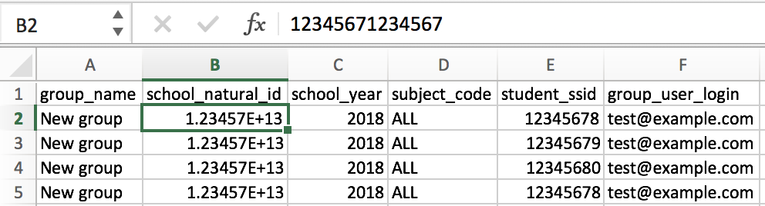

Figure 118. CSV file with problematic scientific notation in Excel

To avoid Excel auto-formatting data in scientific notation, the column must be formatted as a number with zero decimal places. Follow these steps to format the school_natural_id column:

1. Highlight the school_natural_id column by selecting the header of the column (B in the example shown).
2. Right-click on any of the highlighted cells (or otherwise bring up the context menu) and select “Format Cells,” as shown in figure 119.

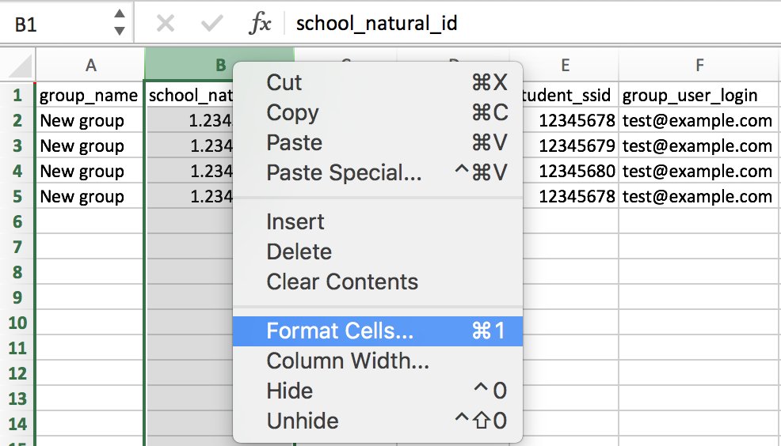

Figure 119. Format Cells option in Excel

1. Select Numberas the Category and update the decimal places value from 2 to 0, as shown in figure 120. Select [**OK**].

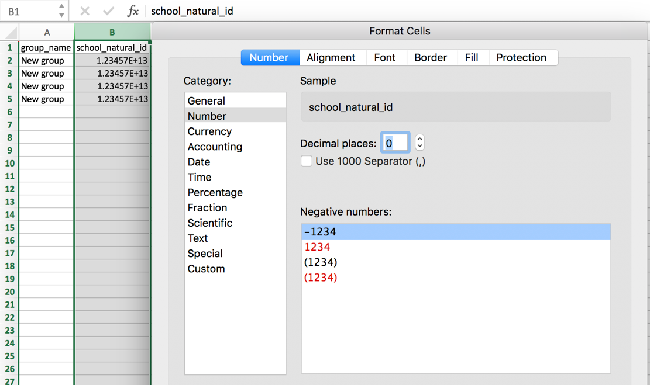

Figure 120. “Number” category and “decimal places” values in Excel.

1. Confirm the value in each cell is displayed as the full number, and not in scientific notation.

#### View Uploads

Selecting the [View Uploads] button on the Manage Student Groups page opens the View Uploads page, shown in figure 121.

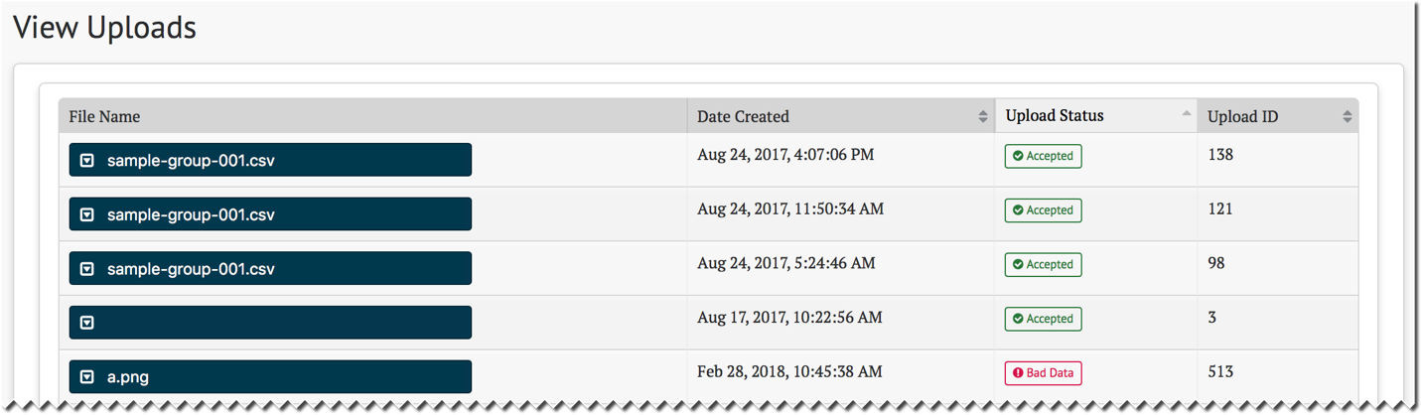

Figure 121. *View Uploads* page

This page shows the results of all of the student group file uploads, from most recent to oldest. If there are no uploaded student group files, the system displays the message “Upload results will be shown here” as shown in figure 122.

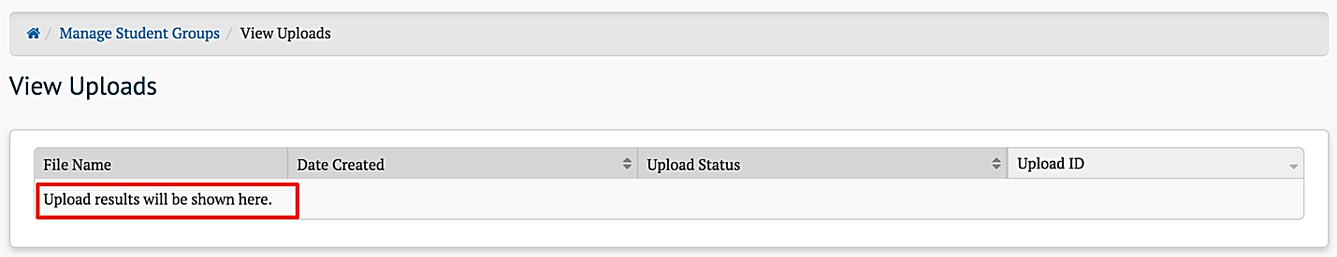

Figure 122. Message when no student group files are uploaded

#### Troubleshooting Common Issues

##### Upload CSV “Bad Data”

The “Bad Data” status informs the user that there was a problem with the uploaded CSV file. Select the [View Errors] button to access more information.

###### Incorrect Headers

The system will display an error message, shown in figure 123, if the order of the column headers does not match the expected order exactly. The message will read as follows:

Message: Row: 0 Failure: Invalid headers. Headers must be in order: group_name, school_natural_id, school_year, subject_code, student_ssid, group_user_login

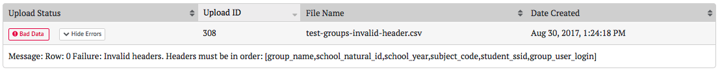

Figure 123. “Invalid Headers” error message

To resolve this error, update the CSV file to ensure the column header names in the first row match the expected names, in the correct order, or use the [CSV File Format] button to download a template.

###### School Cannot Be Found

The system will display an error message, shown in figure 124, if it cannot find a school associated with the uploaded school_natural_id value. The message will read similarly to what follows:

Message: Row: 1 Failure: School [1.23457E+13] cannot be found

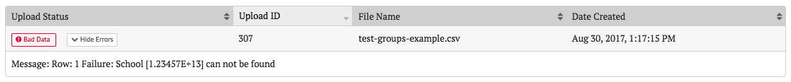

Figure 124. “School cannot be found” error message

* To resolve this error, update the CSV file to include a valid school identifier. If the school listed in the error message is in scientific notation (e.g., 1.23457E+13) it is likely that Excel was used to create or view the file and the column value was automatically formatted by Excel. Refer to this Tip above.

Working with Upload Files in Microsoft Excel for instructions on correcting this issue.

### Manage Instructional Resources

Administrators with the INSTRUCTIONAL_RESOURCE_ADMIN permission can manage the repository of links to Instructional Resources. The *Manage Instructional Resources* page is accessed by the selecting the [Instructional Resources] button on the home page.

The Manage Instructional Resources page elements are shown in figure 125.

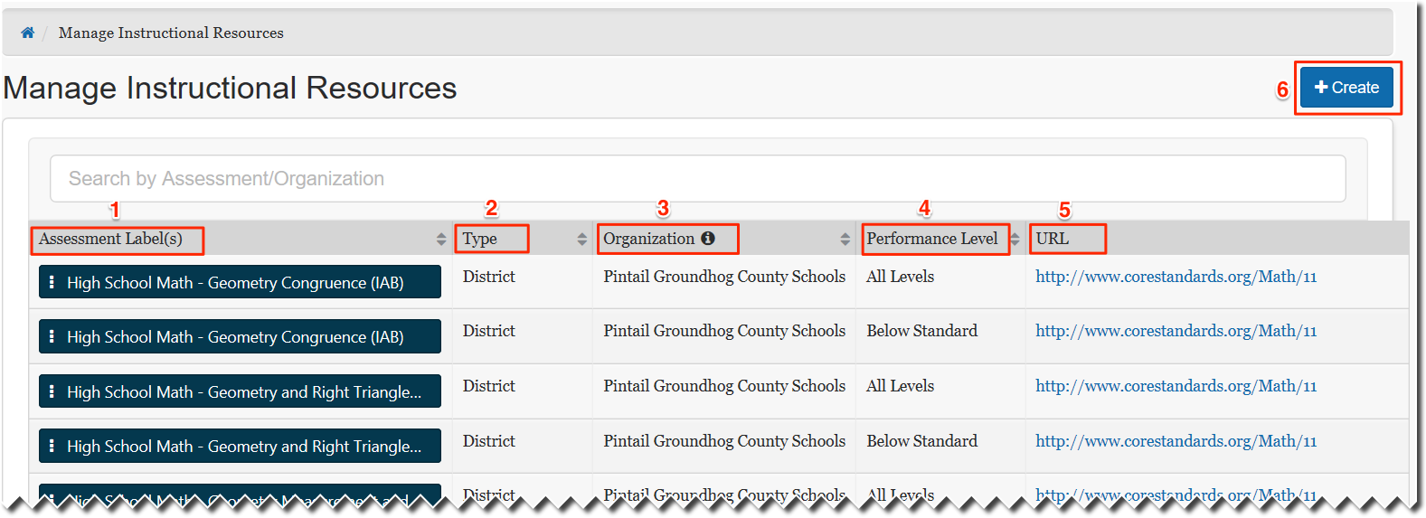

Figure 125. Manage Instructional Resources page

This page shows the available Instruction Resources, with the following information:

1. Assessment Label(s): Name(s) of the assessment with which the resource is affiliated
2. Type: Options are State, Group of Districts, District, or Group of Schools
3. Organization: The name of the organization
4. Performance Level: The performance level(s) associated with the resource
5. URL: The location of the resource
6. [Create **button**]: Allows the user to add a new resource (Selecting this button opens the pop-up screen shown in figure 126.)

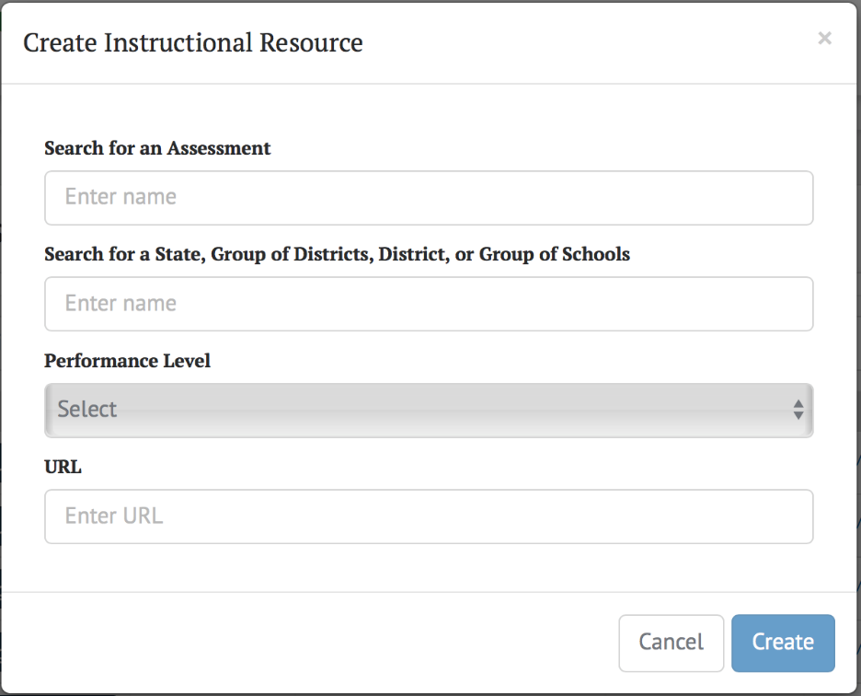

Figure 126. Create Instructional Resource pop-up screen

When the [**Context Menu**] three dot icon [] on an Assessment Label is selected, two options are presented for that resource: Edit or Delete. Selecting Edit brings up a similar pop-up screen as displayed when the [Create] button is selected, except that the menu elements are auto-filled with the existing information for the selected resource. The user may then edit that information. Delete allows the resource to be deleted.

### Manage Embargoed Results

This feature allows state or LEA administrators to restrict access to all summative subjects by year, allowing test results to be collected without releasing them for viewing or analysis until the tests have been administered to all the students.

Permissioned users can control when the annual embargo is lifted for the district or state. The embargo administrator may also preview the test results online prior to releasing them for all users.

The Manage Embargo page is accessed by selecting the [**Embargo**] button on the home page.

Examples of embargo management by state and district are shown in figure 127 and figure 128.

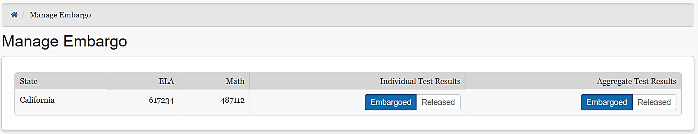

Figure 127. Embargo management by state

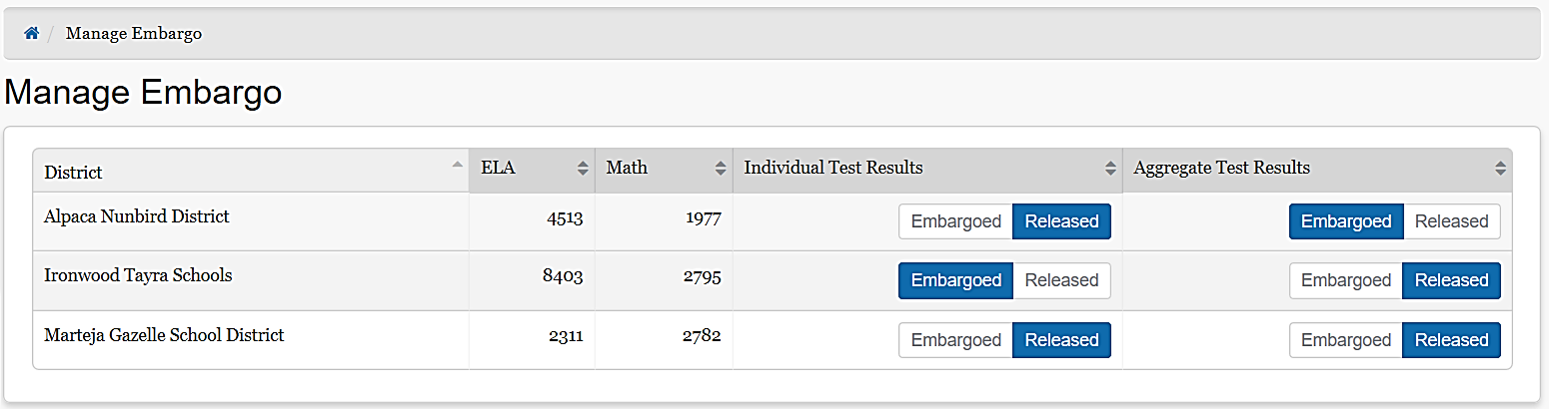

Figure 128. Embargo management by LEA

## Technical Support

CalTAC for LEA CAASPP Coordinators and LEA ELPAC Coordinators

California Assessment of Student Performance and Progress (CAASPP) and English Language Proficiency Assessments of California (ELPAC) test site coordinators and test administrators should contact their local educational agency (LEA) CAASPP coordinators for assistance.

California Technical Assistance Center (CalTAC) Help Desk for LEA CAASPP Coordinators and LEA ELPAC Coordinators Monday through Friday, 7 a.m.–5 p.m. Pacific time

Toll-free telephone support: 800–955–2954 Email support: [caltac@ets.org](mailto:caltac@ets.org)

Chat through the website: <http://www.caaspp.org/contact/> or [http://elpac.org](http://elpac.org/)

## Appendix — Sandbox

The California Educator Reporting System (CERS) Sandbox is a training tool that allows users to familiarize themselves with and explore the features of CERS using simulated assessment data. The Sandbox operates in an environment like CERS, using generated mock data, with almost all of the same features described in the user guide.

The Sandbox was created for training and demonstrations of CERS. This appendix highlights the Sandbox-specific functions. The main CERS User Guide should be referenced for general feature demonstrations.

### Generated Data

The Sandbox uses data sets with simulated data. The tests, organizations, and students are all simulated. The tests use English language arts/literacy and mathematics practice items developed by Smarter Balanced. Interim Assessment Blocks (IABs), Interim Comprehensive Assessments (ICAs), and summative assessments are included in the Sandbox. Student performance is artificial but consistent: for example, a student who is good at mathematics for one year will continue to be good at mathematics in subsequent years. Some item responses may contain mock data, especially for text found in short answer and writing extended response items.



**Note:** The Sandbox does not contain real data. There is no proprietary information and no personally identifiable information (PII) in the Sandbox.

Because the Sandbox uses simulated data, users should not infer anything about performance from the reports. The practice tests are similar to, but different from, the production tests. Extrapolating details from these tests is not appropriate. The Sandbox should be used only to explore and familiarize users with the features of CERS.

### User Roles and Permissions

As discussed at the beginning of the CERS user guide, access to student information in CERS depends on the user’s role and the school(s) and local educational agency (LEA) with which the user’s account is associated. The Sandbox is a public website that is not part of the Single Sign-On (SSO) system. A single user may access any role. The user roles and related permissions are listed below:

* **Teacher:** This role is granted to users who enter a Sandbox as a teacher. The user can choose to access results for students as an elementary, middle, or high school teacher. The assigned group for the user will have students who have taken assessment at these grade levels.
* **School Admin:** This role is granted to users who enter a Sandbox as a school administrator. The user can choose to access results for students in a demo elementary, middle, or high school site.
* **District Admin:** This role is granted to users who enter a Sandbox as an LEA administrator. The user will access results for students within a demo district.

### Sandbox Logon

The CERS Sandbox is available on a public website and no logon credentials are needed to access it. Instead of the SSO-backed logon screen, a Sandbox entry screen will appear (refer to figure 129).

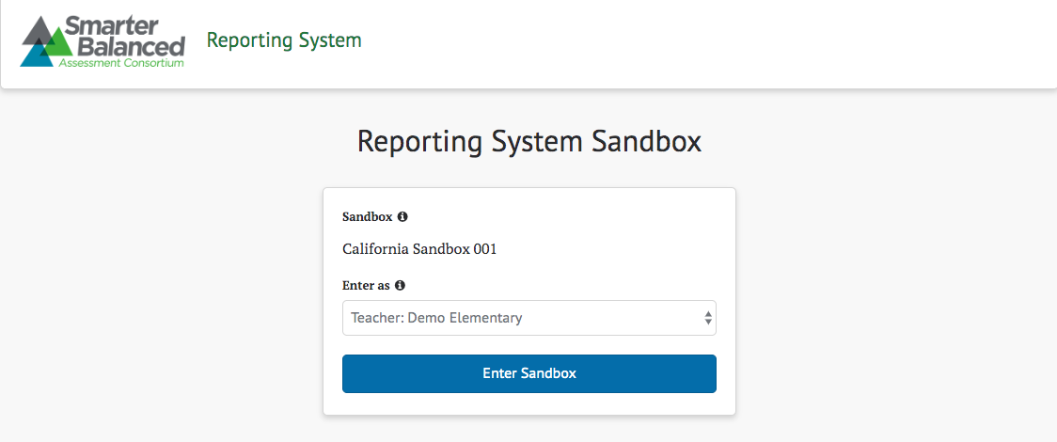

Figure 129. CERS Sandbox entry screen

From the *Enter as* drop-down list, select a user type based on the reporting system functionality to be explored (refer to figure 130). Each user type is associated with a user role in the permission service, allowing the system to customize available functionality. The recommended configuration provides the following functionality for each user type:

* Teacher (Demo Elementary, Demo Middle, or Demo High School)
* View assessment results for individual students and students in assigned groups
* Create custom groups of students that are in the teacher’s assigned groups
* School Admin (Demo Elementary, Demo Middle, or Demo High School)
* View individual test results for students in a selected demo school
* Create custom aggregate reports for a selected demo school
* Export a demo school’s test results for analysis in another application
* District Admin (Demo District)
* View individual test results for all schools in a demo district
* Create custom aggregate reports for the demo district or any demo schools in the demo district
* Export test results for the demo district or the demo schools for analysis in another application
* Manage student groups, instructional resources, and embargo settings

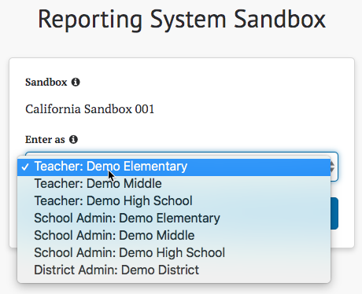

Figure 130. User role drop-down list

Each user who enters the Sandbox is distinct even if multiple users have the same role. That is, multiple users may enter the CERS Sandbox with the same role without affecting each other or anyone else in the Sandbox.

### Sandbox Session Data

Any user-specific data created in the sandbox will be removed upon logoff. This includes custom groups, reports, and saved queries. The session will time out if there is no activity. To avoid lost work, the system will prompt the user to continue working (refer to figure 131).

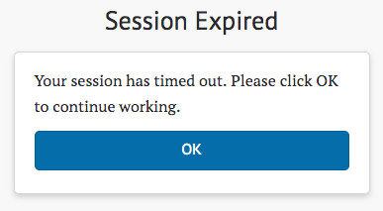

Figure 131. Prompt to continue working

**Caution:** Data that is not user-specific, such as Assigned Groups, Instructional Resources, and Embargo settings, is not considered session data and is retained across all users. Administrators should use caution when manipulating that data since doing so will permanently affect all users of the Sandbox.

